I Am Woman (Ray Burton / Helen Reddy)

G C
I am woman, hear me roar,
Bm Em
In numbers too big to ignore;
C G C D
And I know too much to go back and pretend
G C
'Cause I've heard it all before,
Bm Em
And I've been down there on the floor;
C G D C7
No one's ever gonna keep me down again

Chorus:
F
Oh, yes I am wise;
Bb F
But it's wisdom born of pain
F
Yes, I've paid the price;
Bb Am
But look how much I gained
Dm Bb Am
If I have to, I can do anything
Gm
I am strong, (strong)
F
I am invincible, (invincible)
Bb G
I am wo - man

G C
You can bend but never break me,
Bm Em
'Cause it only serves to make me;



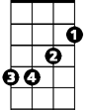
C G C D
G
Em
C
Bm
BARITONE
More determined to achieve my final goal
G C
And I come back even stronger,
Bm Em
Not a novice any longer;
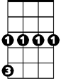
C
Gm



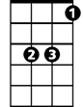
'Cause you've deepened
Dm
F
Am
Bb
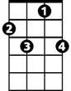
G D C7
C7
The conviction in my soul

(Chorus)

G C
I am woman watch me grow,
Bm Em
See me standing toe to toe;
C G C D
As I spread my lovin' arms across the land
G C
But I'm still an embryo,
Bm Em
With a long long way to go;
C G D C7
Until I make my brother understand

(Chorus)

Gm
I am strong, (strong)
F
I am invincible, (invincible)
Bb G


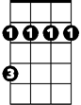

I am wo - man
D
C7
C
G
Bb
Am
F
Gm
Dm
Bm
Em
D

