I Am a Pilgrim (Doc Watson) Key G
Intro: Chords for verse

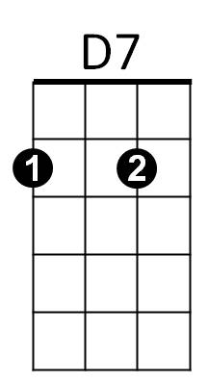

Chorus:
G
C

G D7 G
I am a pilgrim and a stranger
C G
Traveling through this wearisome land
C
I've got a home in that yonder city good Lord
G / TACET D7 / G
/ = Single strum
And it's not ~ Oh Lordy it’s not, not made by hand

D7 G
I've got a mother a sister and brother
C G
Who have gone to that other shore
C
I am determined to go and see them good Lord
G/ TACET D7/ G
And live Good Lordy with them - forevermore

D7 G
I'm going down to that river of Jordan
BARITONE
C G

Just to bathe my wearisome soul
D7
G
C
If I could just touch the hem of His garment good Lord
G/ TACET D7/ G
Then I know - Oh Lordy, I know, He'll make me whole


D7 G
C
Now when you’ve laid me down in my coffin
C G
With these old tired hands resting on my breast
C
I don’t want you to do that ol’ crying over me
G/ TACET D7/ G
Because you know - Oh Lordy, you know, I’ve gone to rest

(Chorus)

