I Can See Clearly Now (Johnny Nash) Key C




C F C
Bb
F
G
C
I can see clearly now the rain is gone
C F G
I can see all obstacles in my way
C F C

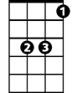

Gone all the dark clouds that had me blind
Am
Eb
G7
Bb F C
It's gonna be a b right, (bright) bright, (bright) sun shiny day
Bb F C
It's gonna be a bright, (bright) bright, (bright) sun shiny day
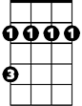
Bm
C F C
I think I can make it now the pain is gone,
C F G
All of the bad feelings have disappeared.
C F C
Here is the rainbow I have been praying for.
B b F C
It's gonna be a bright, (bright) bright, (bright) sun shiny day

Eb Bb
Look all around, there's nothing but blue skies
Eb G7 Bm F Bm F C Am G7
Look straight ahead, there's nothing but blue skiiiiiiiiiiiiiiiiiiiiiiiies
BARITONE
C F C
Bb
G
F
C
I can see clearly now the rain is gone
C F G
I can see all obstacles in my way
C F C
Gone all the dark clouds that had me blind
Bb F C

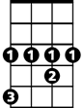

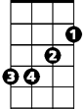
It's gonna be a bright, (bright) bright, (bright) sun shiny day (3x)
Am
Eb
G7
Bm

I Can See Clearly Now (Johnny Nash) Key D

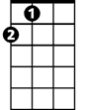
D G D
D
A
G
C
I can see clearly now the rain is gone
D G A
I can see all obstacles in my way
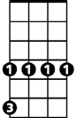
D G D
C#m
Gone all the dark clouds that had me blind
F
C G D
It's gonna be a bright, (bright) bright, (bright) sun shiny day
C G D
It's gonna be a bright, (bright) bright, (bright) sun shiny day

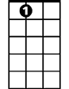
D G D
A7
Bm
I think I can make it now the pain is gone,
D G A
All of the bad feelings have disappeared.
D G D
Here is the rainbow I have been praying for.
C G D
It's gonna be a bright, (bright) bright, (bright) sun shiny day

F C
Look all around, there's nothing but blue skies
F A7 C#m G C#m G C Bm A7
Look straight ahead, there's nothing but blue skiiiiiiiiiiiiiiiiiiiiiiiies
BARITONE
D G D
G
D
A
C
I can see clearly now the rain is gone
D G A
I can see all obstacles in my way
D G D
Gone all the dark clouds that had me blind
C G D
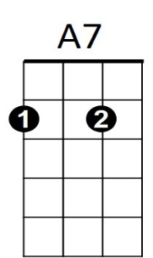
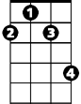
It's gonna be a bright, (bright) bright, (bright) sun shiny day (3x)
Bm
C#m
F

I Can See Clearly Now (Johnny Nash) Key G
G C G
G
C
F
D
I can see clearly now the rain is gone
G C D
I can see all obstacles in my way
G C G
Gone all the dark clouds that had me blind
F#m
Bb
F C G
It's gonna be a bright, (bright) bright, (bright) sun shiny day
F C G
It's gonna be a bright, (bright) bright, (bright) sun shiny day
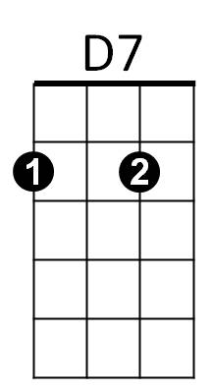
Am
G C G
I think I can make it now the pain is gone,
G C D
All of the bad feelings have disappeared.
G C G
Here is the rainbow I have been praying for.
F C G
It's gonna be a bright, (bright) bright, (bright) sun shiny day

Bb F
Look all around, there's nothing but blue skies
Bb D7 F#m C F#m C F Am D7
Look straight ahead, there's nothing but blue skiiiiiiiiiiiiiiiiiiiiiiiies
BARITONE
G C G
G
C
D
F
I can see clearly now the rain is gone
G C D
I can see all obstacles in my way
G C G
Gone all the dark clouds that had me blind
F C G
It's gonna be a bright, (bright) bright, (bright) sun shiny day (3x)
D7
Am
F#m
Bb

