I Feel Fine (Lennon / McCartney)




Intro: C Bb G
C
Bb
G

G
Baby's good to me, you know,
D
She’s happy as can be, you know, she said so.
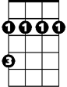


C7 G
Bm
C7
D
I'm in love with her and I feel fine.

G
Baby says she's mine, you know,
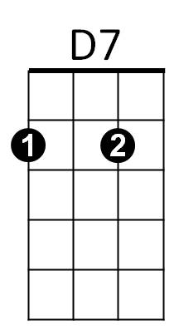

D
Am
She tells me all the time, you know, she said so.
C7 G
I'm in love with her and I feel fine.

G Bm C D7
I'm so glad that she's my little girl.
G Bm Am D7
She's so glad, she's telling all the world.

G
That her ba by buys her things, you know,
D
BARITONE
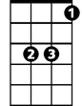

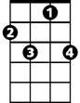

He buys her diamond rings, you know, she said so.
G
Bb
C
D
C7
D7
D7 C7 G
She's in love with me and I feel fine.

Instrumental verse

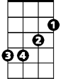
Repeat from 2d verse
Bm

D7 C7 G
She's in love with me and I feel fine.

Am

