I Got the Sun in the Morning (Irving Berlin)

A7 D A7 D
Got no diamond, got no pearl
A7 D E7 D
Still I think I'm a lucky girl
D G A7 D
I got the sun in the morning and the moon at night
D G A7 D
I got the sun in the morning and the moon at night
A7 D A7 D
Got no mansion, got no yacht
A7 D E7 D
Still I'm happy with what I've got
D G A7 D
I got the sun in the morning and the moon at night
D G A7 D
I got the sun in the morning and the moon at night

F#7 B7
Sunshine gives me a lucky day
E7 A7
Moonlight gives me the Milky Way
A7 D A7 D
Got no checkbooks, got no banks
A7 D E7 D
Still I'd like to express my thanks
D G A7 D
I got the sun in the morning and the moon at night
D G A7 D
I got the sun in the morning and the moon at night
D G
And with the sun in the morning
Em7 A7 Em7 A7 D
And the moon in the evening - I'm all right

A7 D A7 D
Got no butler, got no maid
A7 D E7 D
Still I think I've been over - paid
D G A7 D
I got the sun in the morning and the moon at night
D G A7 D
I got the sun in the morning and the moon at night
A7 D A7 D
Got no silver, got no gold
A7 D E7 D
What I got can't be bought or sold
D G A7 D
I got the sun in the morning and the moon at night
D G A7 D
I got the sun in the morning and the moon at night
F#7 B7
Sunshine gives me a lucky day
E7 A7
Moonlight gives me the Milky Way
A7 D A7 D
Got no checkbooks, got no banks
A7 D E7 D
Still I'd like to express my thanks
D G A7 D
I got the sun in the morning and the moon at night
D G
And with the sun in the morning
Em7 A7 Em7 A7 D
And the moon in the evening - I'm all right
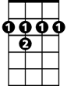
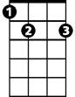

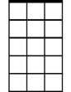

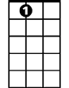
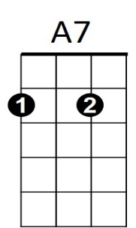
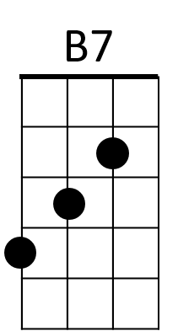
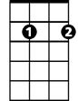
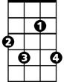

BARITONE
F#7
B7
D
Em7
G
E7
Em7
F#7
G
A7
E7
D

