I Guess That's Why They Call It the Blues
(Elton John, Davey Johnstone, Bernie Taupin)
Intro: C G F 2x

G
Don't wish it away
Bm F C F C F C F C
Don't look at it's like it's forever
C G Bm
Between you and me I could honestly say

F C F C F C F C
C
That things can only get better
C G
And while I'm away,
B7 Em
Dust out the demons inside


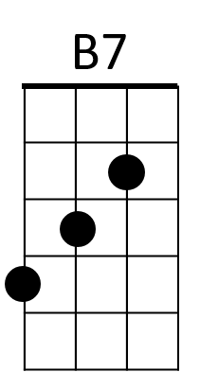
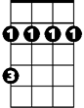
C
G
F
Bm
And it won't be long
Em G
Before you and me run
Am
To the place in our hearts
F G C G Am G
Where we hide

Chorus:
C
And I guess that's why
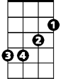
G F
Em
They call it the blues
C
Time on my hands,
G F
Could be time spent with you

C G
Am
Laughing like children,
Am
Living like lovers,
C F
Rolling like thunder,

D
Am
under the covers
F
And I guess that's why
C G Em F
They call it the blues

G
Just stare into space
Em F C F C F C F C
Picture my face in your hands
C G Bm
Live for each second without hesitation
F C F C F C F C
And never forget I'm your man
C G
Wait on me girl
B7 Em G
Cry in the night if it helps
G7 C G
But more than ever I simply love you
Am F G C G Am G
More than I love life itself
(Chorus)
C G
Wait on me girl
B7 Em G
Cry in the night if it helps
G7 C G
But more than ever I simply love you
Am F G C G Am G
More than I love life itself
(Chorus)
(2x)
F G C
And I guess that's why they call it the blues
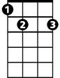

Em
B7
Bm
F
G
C
BARITONE

