

I Heard It In The Graveyard

Intro: Dm //// G7 / Dm / - Dm // G7 //  Dm //// G7 / Dm / A  A Dm G7 Dm A G7  Ooh, ooh, I can tell by the spooky moon Hallo-ween is comin’ soon  Dm G7 Dm A G7  Werewolves howl and run around Zombies crawl from under ground  Bm7 G7 Dm G7  Witching night is almost here And you don’t got a thing to fear  Dm G7 Dm A G7  Dontcha know I heard it in the Grave yard. having fun just ain’t that hard  Dm G7 Dm  Ooh, ooh, I heard it in the grave yard  G7 Dm  Time to stroll out from the boulevard, Mummy, mummy yeah  Dm  (I know that roaming streets at night could cause some folks to get a fright)  A Dm G7 Dm A G7  Ooh, ooh, I heard it in the grave yard, having fun just ain’t that hard  Dm G7 Dm  Ooh, ooh, I heard it in the grave yard  G7 Dm  Time to stroll out from the boulevard, Mummy, mummy yeah  Dm A  (Candy corn and other sweets will fill my bag with lots of treats) Ooh oooh ooh  Dm G7 Dm A7 Dm G7 Dm A7  Heard it in the grave yard , oh yeah, I heard it in the grave yard!  Dm G7 Dm A7 Dm /  Heard it in the grave yard! (Werewolf howl!) |  |  |  |  |  |  | 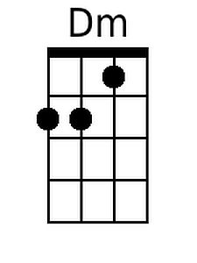
 |  |  |  |  |  |  | 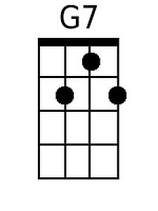
 |  |  |  |  |  |  | 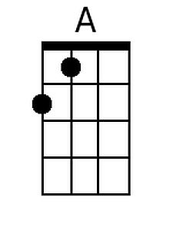
 |  |  |  |  |  |  | 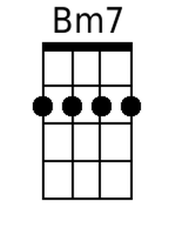
Baritone | 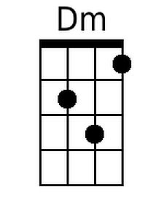 | 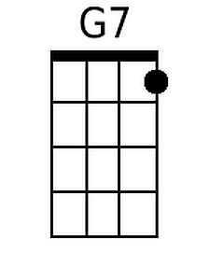 | 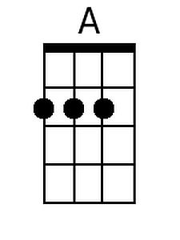 | 