I Love You More Today Than Yesterday (Patrick Upton)
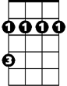

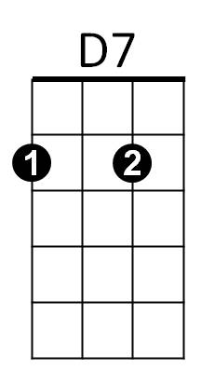
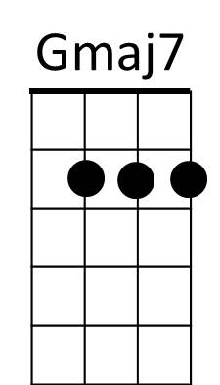

Intro: G Am D7 x2
Bm
Am
G

G Gmaj7 Am D7
I don't remember what day it was
G Gmaj7 Am D7
I didn't notice what time it was
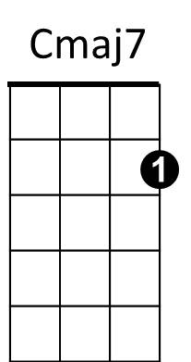
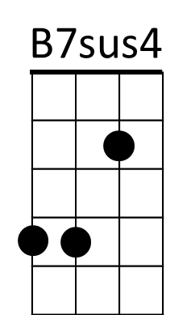
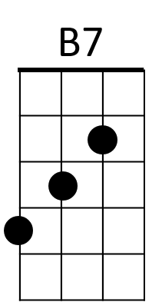
G Gmaj7 Am D7
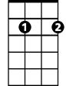
All I know is that I fell in love with you
Em7
Bm Cmaj7
And if all my dreams come true
Am D7
I'll be spending time with you

G Gmaj7 Am D7
Every day's a new day in love with you
G Gm aj7 Am D7
With each day comes a new way of loving you
G Gmaj7 Am D7
Every time I kiss your lips my mind starts to wander
Bm Cmaj7
And if all my dreams come t rue
Am D7
BARITONE

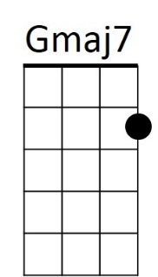

I'll be spending time with you
Am
G

Chorus:
Cmaj7 B7sus4 B7
Oh, I love you more today than yes – ter - day
Cmaj7 Am B7sus4 B7
But not as much as tomorrow
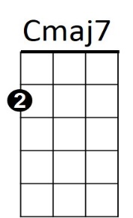
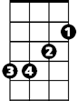

Cmaj7 B7sus4 B7
Bm
D7
I love you more today than yes – ter - day
Em7 A C D7
But, darling, not as much as tomorrow

G Gmaj7 Am D7
Tomorrow's date means springtime's just a day away
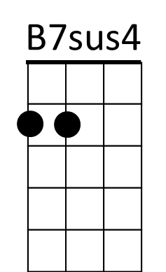
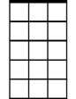
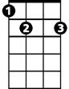
G Gmaj7 Am D7
Em7
B7
Cupid, we don't need ya now, be on your way
G Gmaj7 Am D7
I thank the Lord for love like ours that grows ever stronger
Bm Am Cmaj7 D7
And I always will be true, I know you feel the same way too

(Chorus)

G Gmaj7 Am D7 3x TO FADE
Every day's a new day, every time I love ya

