I Only Want To Be With You (Ivor Raymonde / Mike Hawker) Key C

C Am
I don't kno w what it is that makes me love you so
C Am
I only know I never want to let you go
F G
'Cause you started something, can't you see
C Am
That ever since we met you've had a hold on me
F G F G C
I happens to be true, I only want to be with you

C Am
It doesn't matter where you go or what you do
C Am
I want to spend each mom ent of the day with you
F G
Look what has happened with just one kiss
C Am
I never knew that I could be in love like this
F G F G C
It's crazy but it's true, I only want to be with you

Bridge:
Fm
You stopped and smiled at me
C
Asked me if I cared to dance
G
I fell into your arms
D7 G7
I didn't stand a chance

C
Now, listen, honey, I just want to be beside you
Am
everywhere
C Am
As long as we're together, honey, I don't care
F G
'Cause you started something, can't you see
C Am
That ever since we met you've had a hold on me
F G F G C
No matter what you do, I only want to be with you

(Chorus)
C
Now hear me darling, I just want to be beside you
Am
everywhere
C Am
As long as we're together, honey, I don't care
F G
'Cause you started something, can't you see
C Am
That ever since we met you've had a hold on me
F G F G C
No matter what you do, I only want to be with you
F G F
I said, no matter, no matter what you do, I only want to
G C
be with you





G
F
Am
C

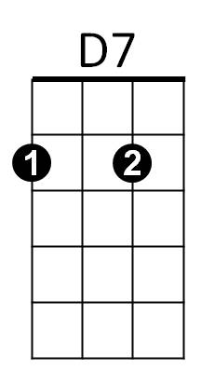

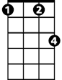
G7
Fm

BARITONE

F

G
Am
C


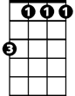
G7
D7
Fm

I Only Want To Be With You (Ivor Raymonde / Mike Hawker) Key F

F Dm
I don't know what it is that makes me love you so
F Dm
I only know I never want to let you go
Bb C
'Cause you started something, can't you see
F Dm
That ever since we met you've had a hold on me
Bb C Bb C F
I happens to be true, I only want to be with you

F Dm
It doesn't matter where you go or what you do
F Dm
I want to spend each moment of the day with you
Bb C
Look what has happened with just one kiss
F
F Dm
I never knew that I could be in love like this
Bb C Bb C F
It's crazy but it's true, I only want to be with you

Bridge:
Bbm
You stopped and smiled at me
Bb m
G7
F
Asked me if I cared to dance
C
I fell into your arms
G7 C7
I didn't stand a chance

F
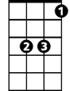
Now, listen, honey, I just want to be beside you
C
Bb

Dm
Dm
F
everywhere
F Dm
As long as we're together, honey, I don't care
Bb C
'Cause you started something, can't you see
F Dm
That ever since we met you've had a hold on me
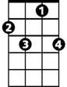
Bb C Bb C F
C7
G7
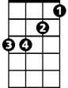
No matter what you do, I only want to be with you
Bb m

(Chorus)

F
Now hear me darling, I just want to be beside you
Dm
everywhere
F Dm
As long as we're together, honey, I don't care
Bb C
'Cause you started something, can't you see
F Dm
That ever since we met you've had a hold on me
Bb C Bb C F
No matter what you do, I only want to be with you
Bb C Bb
I said, no matter, no matter what you do, I only want to
C F
be with you
Bb
Dm
C
BARITONE

