I Want You, I Need You, I Love You (Maurice Mysels and Ira Kosloff)

Intro: F A7 D7 G (hold)

C Am
Hold me close, hold me tight,
Dm G7
Make me thrill with delight
C C7 F
Let me know where I stand from the start
Fm7 A7
I want you, I need you, I love you
D7 G
With all my heart

F
C Am
Every time that you're near,
Dm G7
All my cares disappear
C C7 F


Darling you're all that I'm living for
Dm
Am
Fm7 A7
I want you, I need you, I love you
D7 G C
More and more

Chorus:
Gm7 C7 F
I thought I could live without romance
Gm7 C7 F
U-u-until you came to me
Am7 D G Em
But now I know, that I will go on
Am7 D G G7
BARITONE

Loving you eternally
F

C Am
Won't you please by my own,
Dm G7
Never leave me alone
C C7 F
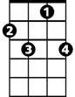

‘Cause I die every time we're apart
C7
Dm
Fm7 A7
I want you, I need you, I love you
D7 G C
With all my heart

(CHORUS)
C Am
Won't you please by my own,
Dm G7
Never leave me alone
C C7 F
‘Cause I die every time we're apart
Fm7 A7
I want you, I need you, I love you
D7 G C
With all - my - heart
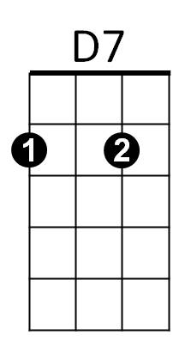
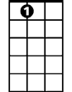


A7
C
G


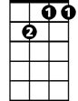
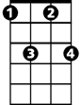

G7
Gm7
Fm7
C7

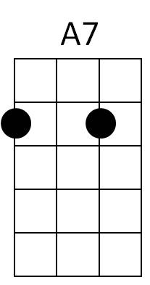
D7
C
G

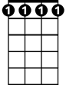
Fm7
G7
Am
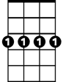
Gm7

