I Will (Lennon / McCartney)
Intro: F G7 Am Em Dm G7 C G7

C Am F G7
Who knows how long I've loved you
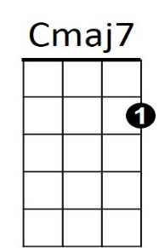
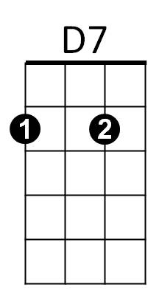



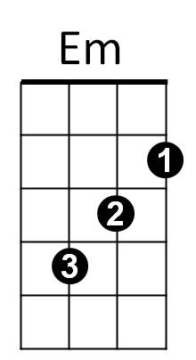

C Am Em C7
Am
G7
F
Dm
You know I love you still
F G7 C C7
Will I wait a lonely lifetime
F G7 C
If you want me to, I will


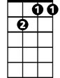
C
C7
Gm7
C Am F G7
For if I ever saw you
C Am Em C7
I didn't catch your name
F G7 C C7
But it never really mattered
F G7 C C7
I will always feel the same

Reprise:
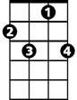
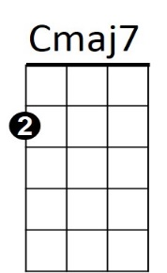
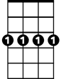


C
C7
Gm7
D7
F
Dm
Em
Am
G7
BARITONE
F Em Am
Love you forever and forever
F G7 C C7
Love you with all my heart
F Em Am
Love you whenever we're together
D7 Dm G7
Love you when we're apart

C Am F G7
And when at last I find you
C Am Em C7
Your song will fill the air
F G7 C Em Am
Sing it loud so I can hear you
F G7 C Em Am
Make it easy to be near you
F G7 Am Em
For the things you do endear you to me
Dm G7 Gm7 C C7
Oh, you know I will - I will

F G7 Am Em Dm G7 Cmaj7
Mm mm mm mm mm mm mmm

