I Will Remember You (Sarah Mclachlan) (Key C)

Intro: C-F-G (2x)

G7
Chorus-

C F G7
I will remember you,
C F G
Will you remember me?
C F C F
Don’t let your life pass you by,
C F G C
Weep not for the me - mories

C F G C
I’m so tired but I can’t sleep
F G C
Standing on the edge of something much too deep
F G C
It’s funny how we feel so much but we cannot say a word
F G C
We are screaming inside, but we can’t be heard

(Chorus)
C F G C
I’m so afraid to love you, but more afraid to lose
F G C
Clinging to a past that doesn’t let me choose
F G C
Once there was a darkness, deep and endless night
F G C
You gave me everything you had, oh, you gave me life

(Chorus 2x)
BARITONE

G7
G
F
C
Outro:
C F G C
Weep not for the me - mories

I Will Remember You (Sarah Mclachlan) (Key G)

Intro: G-C-D (2x)
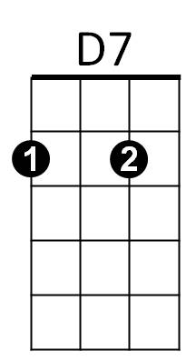
Chorus-

G C D7
I will remember you,
G C D
Will you remember me?
G C G C
Don’t let your life pass you by,
G C D G
Weep not for the me - mories

G C D G
I’m so tired but I can’t sleep
C D G
Standing on the edge of something much too deep
C D G
It’s funny how we feel so much but we cannot say a word
C D G
We are screaming inside, but we can’t be heard

(Chorus)
G C D G
I’m so afraid to love you, but more afraid to lose
C D G
Clinging to a past that doesn’t let me choose
C D G
Once there was a darkness, deep and endless night
C D G
You gave me everything you had, oh, you gave me life

(Chorus 2x)
BARITONE
D7
D
C
G
Outro:
G C D G
Weep not for the me - mories

