I Will Survive (Freddie Perren, Dino Fekaris) (Am)
I Will Survive by Gloria Gaynor (1978 Official Video, 3:17)
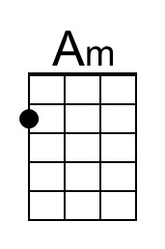
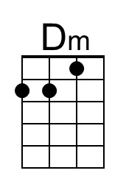
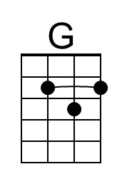
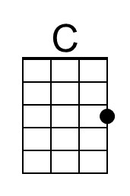
Intro (2 measures) Am Dm

Am Dm
1. First I was afraid, I was petrified.
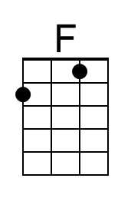
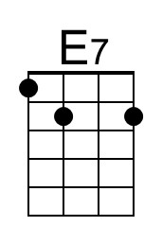
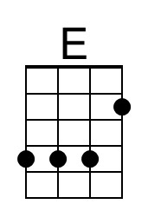
G C
Kept thinking I could never live without you by my side.
F Dm
But then I spent so many nights thinking how you did me wrong.
E E7
And I grew strong, and I learned how to get along.

Am Dm
2. And so you're back back from outer space.
G C
I just walked in to find you here with that sad look upon your face.
F Dm
I should have changed that stupid lock, I should have made you leave your key,
E E7
If I had known for just second you'd be back to bother me.

Am Dm G C
3. Go on now go, walk out the door. Just turn around now, cause you're not welcome anymore.
F Dm
Weren't you the one who tried to hurt me with goodbyes?
E E7
Did you think I'd crumble? Did you think I'd lay down and die?

Am Dm G C
4. Oh no not I! I will survive. Oh, as long as I know how to love I know I'll stay alive.
F Dm E E7
I've got all my life to live, I've got all my love to give. And I'll survive, I will survive – hey, hey.
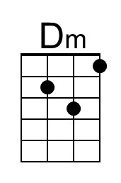
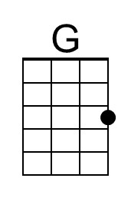
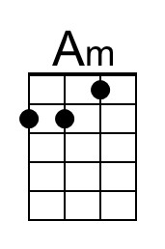
Instrumental Verse

Am Dm
5. It took all the strength I had not to fall apart.
G C
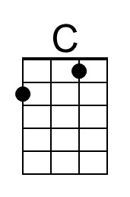
Kept trying hard to mend the pieces of my broken heart.
F Dm
And I spent oh so many nights just feeling sorry for myself.
E E7
I used to cry, but now I hold my head up high.

Am Dm G C
6. And you see me, somebody new. I'm not that chained up little person still in love with you.
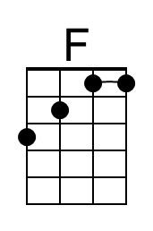
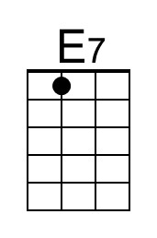
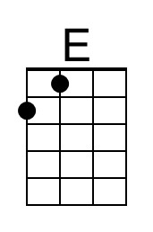
F Dm
And so you felt like dropping in, and just expect me to be free.
E E7
And now I'm savin' all my lovin' for someone who's lovin' me.

Repeat Verses 3 and 4 (2x)
I Will Survive (Freddie Perren, Dino Fekaris) (Em)
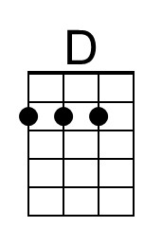
I Will Survive by Gloria Gaynor (1978 Official Video, 3:17)
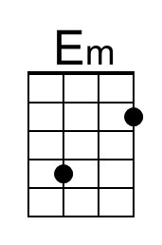
Intro (2 measures) Em Am

Em Am
1. First I was afraid, I was petrified.
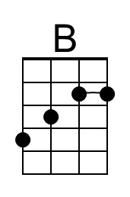
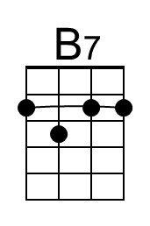
D G
Kept thinking I could never live without you by my side.
C Am
But then I spent so many nights thinking how you did me wrong.
B B7
And I grew strong, and I learned how to get along.

Em Am
2. And so you're back back from outer space.
D G
I just walked in to find you here with that sad look upon your face.
C Am
I should have changed that stupid lock, I should have made you leave your key,
B B7
If I had known for just second you'd be back to bother me.

Em Am D G
3. Go on now go, walk out the door. Just turn around now, cause you're not welcome anymore.
C Am
Weren't you the one who tried to hurt me with goodbyes?
B B7
Did you think I'd crumble? Did you think I'd lay down and die?

Em Am D G
4. Oh no not I! I will survive. Oh, as long as I know how to love I know I'll stay alive.
C Am B B7
I've got all my life to live, I've got all my love to give. And I'll survive, I will survive - hey, hey.
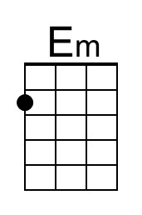
Instrumental Verse

Em Am
5. It took all the strength I had not to fall apart.
D G
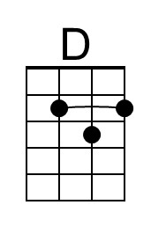
Kept trying hard to mend the pieces of my broken heart.
C Am
And I spent oh so many nights just feeling sorry for myself.
B B7
I used to cry, but now I hold my head up high.

Em Am D G
6. And you see me, somebody new. I'm not that chained up little person still in love with you.
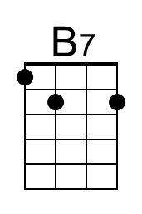
C Am
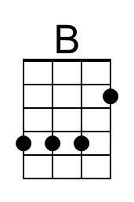
And so you felt like dropping in, and just expect me to be free.
B B7
And now I'm savin' all my lovin' for someone who's lovin' me.

Repeat Verses 3 and 4 (2x)

