I Wish You Love (Paul Young)

Bm C
Goodbye, no use leading with our chins

Bm Em
This is how our story ends
Am D
Never lovers, ever friends

Bm C
Goodbye, let our hearts call it a day
Bm Em
But before you walk away
Am D
I sincerely want to say -

D C D
I wish you blue birds in the spring
G Em
To give your heart a song to sing
C D
And then a kiss, but more than this
G G7
I wish you love

C D
And in July a lemonade
G Em
To cool you in some leafy glade
C D
I wish you health, and more than wealth,
G7
I wish you love
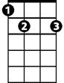


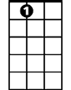




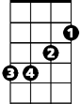
B7
Am
G7
E7
Em
C
G
D
BARITONE
Bm
Bridge:
C B7
My breaking heart and I agree
G E7
That you and I could never be
C E7
So, with my best, my very best
Dsus D
I set you free

C D
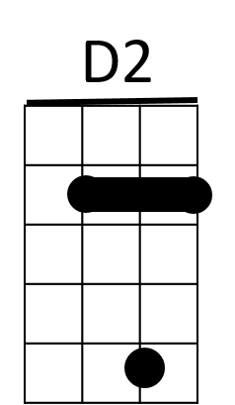
I wish you shelter from the storm
B7
E7
G Em
A cozy fire to keep you warm
C D
But most of all, when snowflakes fall
G7
I wish you love

(Repeat from Bridge)

C D
But most of all, when snowflakes fall
G
I wish you love

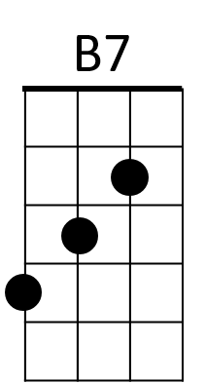

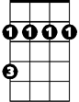

Am
E7
G
D
Em
C
Bm
G7

