Wonder Where My Little Hula Girl Has Gone
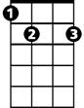

G E7 A7
E7
G
I... wonder where... my little hula girl has gone.
D7 G D7 C D7
She’s no longer on the beach at Waiki-ki.
G E7
I... comb the beach...
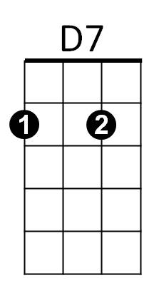
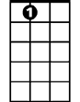
A7
A7
And watch the surf that she rode upon
D7 G G7
And I looked around as far as I can see

C Am G E7


She flew to the East, and she flew to the West
G7
C
A7
But, I’ll... get no rest
D7 Gdim D7
Until I find her back in my little grass shack, oh
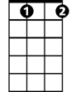

G E7 A7
Gdim
Am
I... wonder where... my little hula girl has gone
D7 G D7 C D7
She’s no longer on the beach at Waiki-ki.

(Repeat first verse)

C Am G E7
She flew to the East, and she flew to the West
A7
But, I’ll... get no rest
D7 Gdim D7
Until I find her back in my little grass shack, oh
G E7 A7
I... wonder where... my little hula girl has gone
D7 G E7
She’s no longer on the beach at Waiki-ki.
A7 D7 G G Gdim G
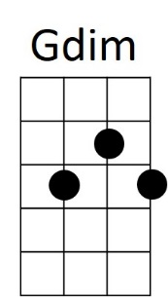



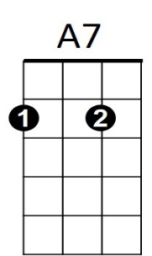
She’s no longer on the beach at Waikiki.
BARITONE
Am
G7
C
D7
E7
G

