I’ll Be Home For Christmas (Hawaiian)
C 23
(K. Gannon & W. Kent; Additional lyrics by Na Leo Pilimehana)

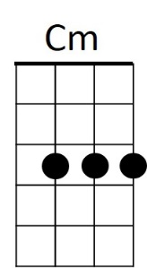
Intro: C Cm G E7 Am7 D7 G D7

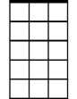
I'll be home for Christmas if only in my dreams
C
Am7

G Bbdim Am7 D7 G E7 Am7 E7
I'll be home for Christmas, you can plan on me
C D7 G Em A7 Am7 D7
Please have snow and mistletoe and presents on the tree


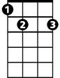
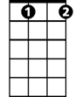
G
E7
Bb dim
G Bbdim Am7 D7 G E7 Am7 E7
Christmas Eve will find me, Where the love light gleams
C Cm G E7
I'll be home for Christmas
A7 D7 G D7
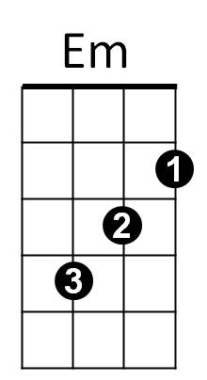
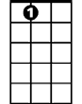
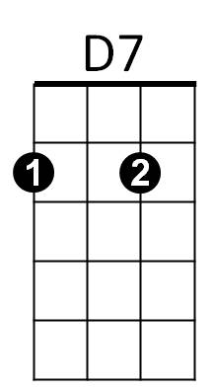
If only in my dreams
A7

G Bbdim Am7 D7 G E7 Am7 E7
I’ll be home for Christmas, that’s where my heart lies
C D7 G Em
Palm trees sway as trade winds play
A7 Am7 D7
As stars light up the sky

G Bbdim Am7 D7 G E7 Am7 E7
BARITONE
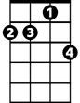

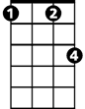
Christmas Eve will find me, on my Island shore
Am7
C
Cm
C Cm G E7
I’ll be home for Christmas
A7 D7 G D7
Then leave you nevermore

G Bbdim Am7 D7 G E7 Am7 E7
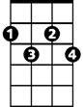
I’ll be home for Christmas, we’ll cele-brate the night
E7
G
Bb dim
C D7 G Em
Wave and sway as guitars play
A7 Am7 D7
Hawaiian Lullabies

G Bbdim Am7 D7 G E7 Am7 E7


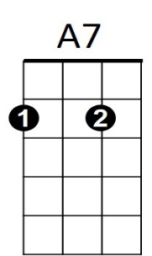
Christmas Eve will find me, draped with leis so sweet
D7
Em
C Cm G E7
I’ll be home for Christmas
A7 D7 G E7
If only in my dreams
A7 D7 G
If only in my dreams

