I’m In Love With A Big Blue Frog
(Lester (Les) Braunstein / Mary Allin Travers / Noel Paul Stookey / Peter Yarrow)

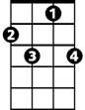

Intro: F F7 Bb Bbm6 F C7 F (C7)
F7
F
F C7
I'm in love with a big blue frog, a big blue frog loves me
F F7 Bb Bbm6 F C7 F. C7
It's not as bad as it appears, he wears glasses and he's six foot three.

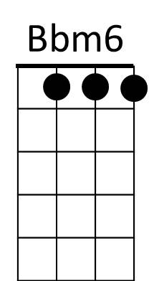

F C7
Bb

Well I'm not worried about our kids,I know they'll turn out neat.
C7
F F7 Bb Bbm6
They'll be great looking cause they'll have my face,
F C7 F C7
Great swimmers cause they'll have his feet!

F C7
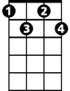
Well I'm in love with a big blue frog,a big blue frog loves me
Bdim
F7
F F7 Bb Bbm6 F C7 F C7
He's not as bad as he appears, he's got rhythm and a Ph D.

F C7
Well I know we can make things work, he's got good family sense
F F7 Bb Bbm6. F C7 F C7
His mother was a frog from Philadel - phia His daddy an enchanted prince.

F C7
The neighbors are against it and it's clear to me and it's probably clear to you
F F7 Bb Bbm6 F C7 F C7
They think value on their property will go right down if the family next door is blue.

F C7
Well I'm in love with a big blue frog , a big blue frog loves me
F F7 Bb Bbm6 F C7 F Bdim F C7 F C7 F
I've got it tattooed on my chest It says P.H.R.O.G. (It's frog to me!) P.H.R.O.G.

I'm in Love With a Big Blue Frog lyrics © Warner Chappell Music, Inc

http://www.traditionalmusic.co.uk/peter-paul-mary/im-in-love-with-a-big-blue-frog-CRD.htm

(complete with slide whistle, kazoo, and bike horn!)
BARITONE
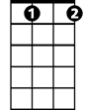
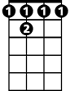
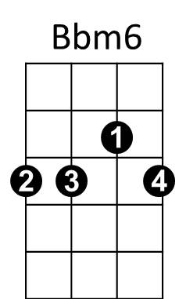
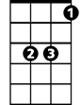
Bdim
C7
F 7
Bb
F

