I’ll Be Home for Christmas
C 22
(K. Gannon & W. Kent, 1943)

Intro: C Cm G E7 Am7 D7 G D7
I'll be home for Christ-mas if only in my dreams

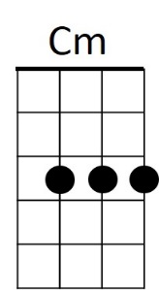
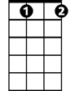

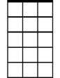
C
Bb dim
G
Am7
G Bbdim Am7 D7
I'll be home for Christmas,
G E7 Am7 E7
You can plan on me
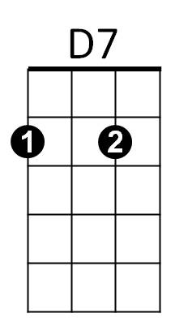
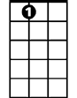
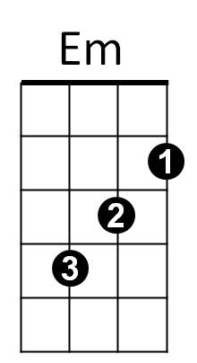
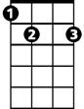
C D7 G Em
A7
E7
Please have snow and mistletoe
A7 Am7 D7
And presents on the tree

G Bbdim Am7 D7
Christmas Eve will find me,
G E7 Am7 E7
Where the love light gleams
C Cm G E7
I'll be home for Christmas
A7 D7 G D7 (D7 to rollover)
If only in my dreams
G7 to Outro
Repeat Entire Song
BARITONE
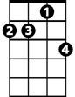
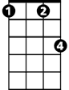

G
Am7
Cm
C
C Cm G E7
I’ll be home for Christmas
A7 D7 G E7
If only in my dreams

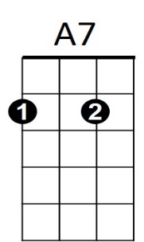

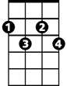
A7 D7 G
E7
D7
Em
Bbdim
If only in my dreams

