I'll Follow the Sun (John Lennon / Paul McCartney)



Intro: C F C
C
F
G

G F C D7
One day you'll look to see I've gone
C Am D7 G7 C F C
For tomorrow may rain so I'll follow the Sun
G F C D7
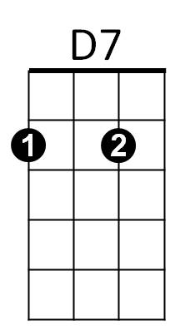


Some day you'll know I was the one
G7
Am
C Am D7 G7 C C7
But tomorrow may rain so I'll follow the sun.

Reprise:


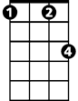
F
C7
Fm
And now the time has come
Fm C C7
And so my love I must go
F
And though I lose a friend
Fm C D7
In the end you will know, Oh -

G F C D7
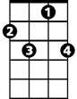


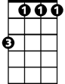
One day you'll find that I have gone
BARITONE
C7
Am
G
F
C
G7
D7
Fm
C Am D7 G7 C F C
But tomorrow may rain so I'll follow the Sun

Solo: G F C D7 (1st line of verse melody)

C Am D7 G7 C C7
Yes, tomorrow may rain so I'll follow the sun.

(Reprise)

Ending:

G F C D7
One day you'll find that I have gone
C Am D7 G7 C F C
But tomorrow may rain so I'll follow the Sun

