I’ll Never Fall in Love Again (Burt Bacharach and Hal David)

C Am
What do you get when you fall in love?
F G
A guy with a pin to burst your bubble
Em A7
That's what you get for all your trouble
F F7 C
I'll never fall in love agai-n
F G C
I'll never fall in love again

C Am
What do you get when you kiss a guy?
F G
You get enough germs to catch pneumonia
Em A7
After you do, he'll never phone ya
F F7 C
I'll never fall in love agai-n
F G C
Dontcha know that I'll never fall in love again?

Bridge:

C F C
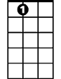
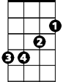
Don't tell me what it's all about
A7
Em
F C
'Cause I've been there and I'm glad I'm out
Em
Out of those chains, those chains that bind you
D G
That is why I'm here to remind you

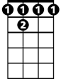




C Am
BARITONE
F 7
D
G
F
Am

What do you get when you fall in love?
C
F G
You only get lies and pain and sorrow
Em A7
So far at least until tomorrow
F F7 C
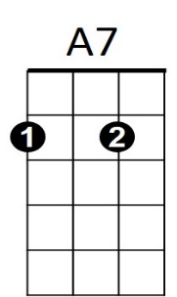
I'll never fall in love agai-n

F G C
Em
No, no, I'll never fall in love again

Instrumental Bridge (first two lines)

Em
Out of those chains, those chains that bind you
D G
That is why I'm here to remind you

C Am
What do you get when you fall in love?
F G
You only get lies and pain and sorrow
Em A7
So far at least until tomorrow
F F7 C
I'll never fall in love agai-n
F G C
Dontcha know that I'll never fall in love again?
F G C

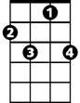
I'll never fall in love again
D
F7
F
Am
C
G

