I'll Remember You (Kui Lee)
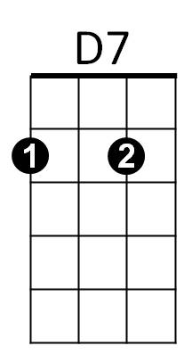

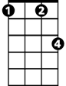
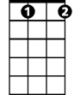



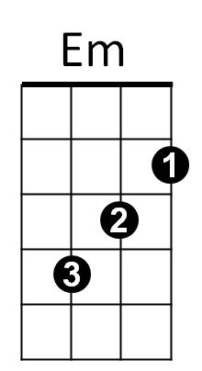
Intro: Chords of Reprise
C7
Fm
Bbdim
G7
C
F
C Em
I'll remember you
F G7 C Bbdim
Long after this endless summer has gone
F Fm
I'll be lonely, oh so lonely
F G7 C Bbdim F G7
Living only to remember you

C Em
I'll remember too
F G7 C Bbdim
Your voice as soft as the warm summer breeze
F Fm
Your sweet laughter, mornings after
F G7 C C7


Ever after, (ooo) I'll remember you
BARITONE
C
Em
F

Reprise:
C7 F
To your arms someday
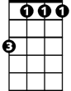
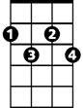
D7 G7 D7 G7
G7
Fm
Bbdim
I'll return to stay ~ Till then - I will re-

C Em
-member, too
F G7 C Bbdim
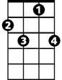
Every bright star we made wishes upon
D7
C7
F Fm
Love me always, promise always
F G7 C
Ooooo ooo, you'll remember too. Repeat From Reprise

Ending: G7 C G7 C F C
You'll remember too, you’ll remember too-oo-oo

