I'll Take You Home Again Kathleen (Thomas P. Westendorf, 1875) Key C




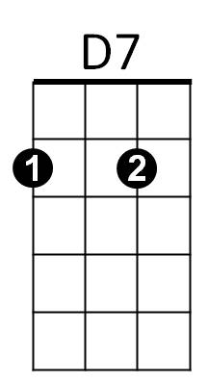
C G7 C
C
G7
F
I'll take you home again Kathleen
G7 C
Across the ocean wild and wide
G7 C


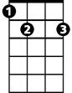
To where your heart has ever been
C7
Am
E7
G7 D7 G7
Since first you were my bonnie bride

F G7 C
The roses all have left your cheek
G7 C
I've watched them fade away and die
E7 Am C
Your voice is sad when ‘ere you speak
D7 G7
And tears bedim your loving eyes

C G7 C
BARITONE
C
D7
Oh, I will take you back Kathleen
G7
G7 C
To where your heart will feel no pain
C7 F
And when the fields are fresh and green
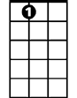


C G7 C
E7
Am
F
I'll take you to your home Kathleen

C7 F
And when the fields are fresh and green
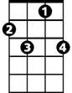
C G7 C
C7
I'll take you to your home Kathleen

I'll Take You Home Again Kathleen (Thomas P. Westendorf, 1875) Key G

C
G
A7
G D7 G
I'll take you home again Kathleen
D7 G
Across the ocean wild and wide
D7 G
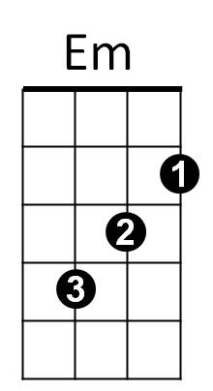
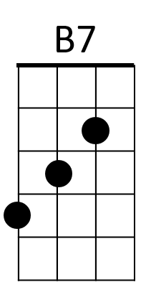
To where your heart has ever been
G7
D7 A7 D7
Since first you were my bonnie bride

C D7 G
The roses all have left your cheek
D7 G
I've watched them fade away and die
B7 Em G
Your voice is sad when ‘ere you speak
A7 D7
And tears bedim your loving eyes

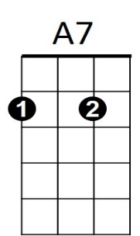
G D7 G
BARITONE
D7
G
Oh, I will take you back Kathleen
D7 G
To where your heart will feel no pain
G7 C
And when the fields are fresh and green
G D7 G
B7
G7
C
I'll take you to your home Kathleen

G7 C
And when the fields are fresh and green
G D7 G
Em
I'll take you to your home Kathleen

