



I'm Going to Go Back There Someday (Paul Williams / Kenny Ascher)
D
G7
Am
C
C G7 Am D
This looks familiar, vaguely familiar,
C G7 Am D
Almost unreal, yet, it's too soon to feel yet.
F G Em7 A


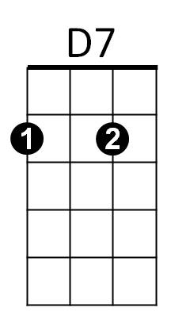

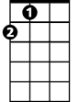
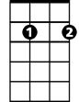
Close to my soul, and yet so far away.
G
F
Dm
A
Em7
Dm G7 C F C
I'm going to go back there someday

C G7 Am D
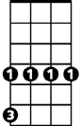
Sun rises, night falls, sometimes the sky calls.
Dbm
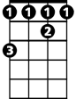
C G7 Am D
F#
Is that a song there, and do I belong there?
F G Em7 A
I've never been there, but I know the way.
Dm G7 C F C
I'm going to go back there someday
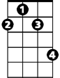
F#m
Am D G
Come and go with me, it's more fun to share,
Am D G
We'll both be completely at home in midair.
Dbm F# F#m
We're flyin', not walkin', on featherless wings.
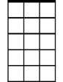
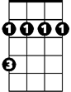
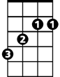



G Dm F G7
BARITONE
Em7
G
F#m
F#
Dbm
Dm
A
D
D7
F
C
Am
G7
We can hold onto love like invisible strings.

C G7 Am D
There's not a word yet for old friends who've just met.
C G7 Am D
Part heaven, part space, or have I found my place?
F G Em A
You can just visit, but I plan to stay.
Dm G7 C F C
I'm going to go back there someday
Dm G7 C
I'm going to go back there someday

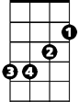
I'm Going to Go Back There Someday (Paul Williams / Kenny Ascher)
A
Em
G
G D7 Em A
This looks familiar, vaguely familiar,
G D7 Em A
Almost unreal, yet, it's too soon to feel yet.
C D Bm7 E7
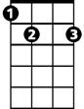
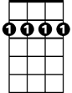
Close to my soul, and yet so far away.
E7
Bm7
D
C
Am D7 G C G
I'm going to go back there someday

G D7 Em A
Sun rises, night falls, sometimes the sky calls.
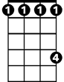
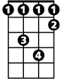
G D7 Em A
Bm
C#
Abm
Am
Is that a song there, and do I belong there?
C D Bm7 E7
I've never been there, but I know the way.
Am D7 G C G
I'm going to go back there someday
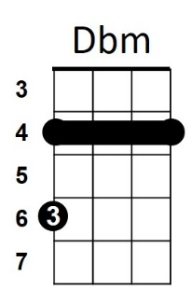
Em A D
Come and go with me, it's more fun to share,
Em A D
We'll both be completely at home in midair.
Abm C# Dbm
We're flyin', not walkin', on featherless wings.
D Am C D7
BARITONE
Em
D7
G
We can hold onto love like invisible strings.

G D7 Em A
There's not a word yet for old friends who've just met.
G D7 Em A
Part heaven, part space, or have I found my place?
C D Bm7 E7
Bm7
D
C
A
You can just visit, but I plan to stay.
Am D7 G C G
I'm going to go back there someday
Am D7 G
I'm going to go back there someday
Abm
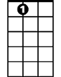
C#
E7
Am
Bm
Dbm

