If I Were a Rich Man (Sheldon Harnick and Jerry Bock)


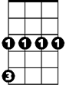
Intro: G
G
Cm

Dear God, you made many, many poor people.
I realize, of course, that it's no shame to be poor~ But it's no great honor, either.
So what would have been so terrible if I had a small fortune?

CHORUS:

Gm
G
If I were a rich man, Daidle deedle daidle, Daidle daidle deedle daidle dum
Cm Gm A7 D
All day long I'd biddy biddy bum, if I were a wealthy man
G
I wouldn't have to work hard, Daidle deedle daidle, Daidle daidle deedle daidle dum
Cm Gm D7 G
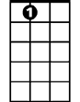
If I were a biddy biddy rich, Daidle deedle daidle daidle man
A7

Cm F7 Bb Gm
I'd build a big tall house with rooms by the dozen, right in the middle of the town
Cm F G (E7)
A fine tin roof with real wooden floors below
Cm F Bb Gm
There would be one long staircase just going up, and one even longer coming down,


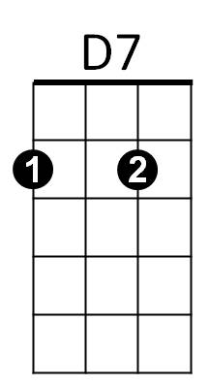
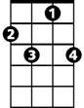
Cm Gdim D
D
Bb
F7
And one more leading nowhere, just for show

Cm F7
I'd fill my yard with chicks and turkeys and geese
Bb Gm
And ducks for the town to see and hear
Cm F G (E7)
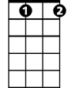

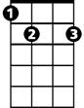
Squawking just as noisily as they can
Gdim
F
E7
Cm F
And each loud "cheep" and "squawk" and "honk" and "quack"
Bb Gm
Would land like a trumpet on the ear,
Cm Gdim D
As if to say, "Here lives a wealthy man"
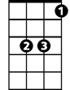

Eb
G7
(Chorus)

Cm F7 Bb Gm
I see my wife, my Golde, looking like a rich man's wife with a proper double chin
Cm F G (E7)
Supervising meals to her heart's delight
Cm F Bb Gm
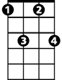
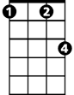
I see her putting on airs and strutting like a peacock, Oh what a happy mood she's in
Fm7
Fm
Cm Gdim D
Screaming at the servants, day and night

(Chorus)

G7 Eb
The most important men in town will come to fawn on me
Cm
They will ask me to advise them, like a Solomon the Wise
Fm Fm7
"If you please, Reb Tevye?" "Pardon me, Reb Tevye?"
G
Posing problems that would cross a rabbi's eyes

Ya va voy, ya va voy voy vum

Cm F Bb Gm
And it won't make one bit of difference if I answer right or wrong
Cm Gdim D
When you're rich they think you really know.

Cm F7 Bb Gm
If I were rich, I'd have the time that I lack to sit in the synagogue and pray,
Cm F G (E7)
And maybe have a seat by the Eastern wall,
Cm F Bb Gm
And I'd discuss the holy books with the learned men, seven hours every day
Cm Gdim D
That would be the sweetest thing of all ~ Oy!

G
If I were a rich man, Daidle deedle daidle, Daidle daidle deedle daidle dum
Cm Gm A7 D
All day long I'd biddy biddy bum, if I were a wealthy man
G
I wouldn't have to work hard, Daidle deedle daidle, Daidle daidle deedle daidle dum
Cm Gm
Lord who made the lion and the lamb,
Cm Gm
You decreed I should be what I am
Cm Gm
Would it spoil some vast, eternal plan,
D D7 G D7 G
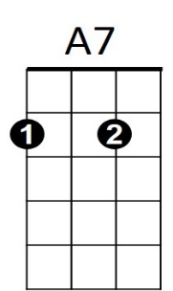
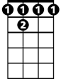
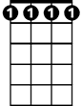
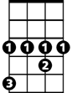

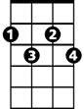

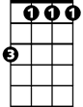
If ~ I were a weal-thy man?
D
D7
F 7
Fm7
Eb
G7
Gdim
E7
Gm
G
Cm
Bb
F
Fm
BARITONE

