I'll Have to Say I Love You in a Song (Jim Croce)

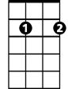


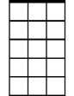

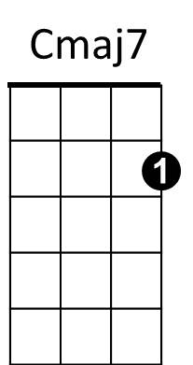

C Cmaj7 Am7 Em7
Em7
F
G7
Am7
C
Dm
Well, I know it's kind of late
Dm G7
I hope I didn't wake you,
Cmaj7 Am7 Em7
But what I got to say can't wait
Dm G7
I know you'd understand

Chorus:

F F#dim
Every time I tried to tell you
E7 Am F
The words just came out wrong
C G7 F C
So I'll have to say I love you in a song.

Cmaj7 Am7 Em7
Yeah, I know it's kind of strange
Dm G7
But every time I'm near you,
Cmaj7 Am7 Em7
I just run out of things to say
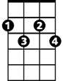
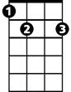

Dm G7
F#dim
E7
Am
I know you'd understand

(Chorus)

(Instrumental Verse)

(Chorus)

C Cmaj7 Am7 Em7
Yeah, I know it's kind of late
Dm G7
I hope I didn't wake you,
Cmaj7 Am7 Em7
But there's something that I just got to say,
Dm G7
I know you'd understand
.
(Chorus)

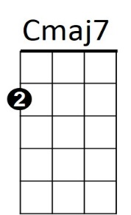
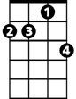
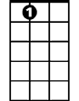
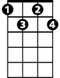


BARITONE
F
Am7
Am
E7
F#dim
G7
Dm
Em7
C

