In My Life (Lennon / McCartney)

C G Am C7
There are places I’ll remember
F Fm C
All my life though some have changed
C G Am C7
Some forever not for better
F Fm C
Some have gone and some remain

Am Dm
All these places have their moments
Bb C
With lovers and friends I still can recall
Am Dm
Some are dead and some are living
F Fm C
In my life I’ve loved them all

C G Am C7
But of all these friends and lovers
F Fm C
There is no one compares with you

C G Am C7
And these memories lose their meaning
BARITONE
F Fm C
When I think of love as something new

Am Dm
Though I know I’ll never lose affection
Bb C
For people and things that went before
Am Dm
I know I’ll often stop and think about them
F Fm C
In my life I love you more

Solo: C G Am C7 / F Fm C 2x

Am Dm
Though I know I’ll never lose affection
Bb C
For people and things that went before
Am Dm
I know I’ll often stop and think about them
F Fm C

In my life I love you more
Am



C7
C
G
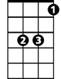

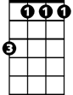

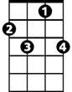


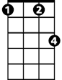
Bb
Dm
Fm
F
C7
C
G
Am
Bb
Dm
Fm
F

