It Never Rains in Southern California (Albert Hammond / Mike Hazlewood) Key C
Dm G C 2x

C Dm G C
Got on a board a westbound 7 - forty- 7
Dm G C
Didn't think before deciding what to do
Dm G
All that talk of oppor-tunities,
C Am
TV breaks and movies
Dm G C
Rang true, sure rang true.

Chorus:
Dm G C Am
Seems it never rains in Southern California
Dm G C
Seems I've often heard that kind of talk before
C7 Dm G

It never rains in California
Dm
C Am
But girls, don't they warn ya
Dm G C
It pours - man, it pours.

Dm G
Out of work, I'm out of my head
C
Out of self respect, I'm out of bread
Dm G
BARITONE

I'm under loved, I'm under fed
Dm
C C7
I wanna go home
Dm G
It never rains in California
C Am
But girls, don't they warn ya
Dm G C
It pours - man, it pours.

Dm G C

Dm G
Will you tell the folks back home
C
I nearly made it
Dm G C
Had offers but don't know which one to take
Dm G
Please don't tell them how you found me
C Am
Don't tell them how you found me,
Dm G C
Give me a break - give me a break

(Chorus)





C
G
C7
Am

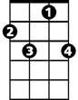

Am
C7
C
G

It Never Rains in Southern California (Albert Hammond / Mike Hazlewood) Key G
Am D G 2x

G Am D G
Got on a board a westbound 7 - forty- 7
Am D G
Didn't think before deciding what to do
Am D
All that talk of oppor-tunities,
G Em
TV breaks and movies
Am D G
Rang true, sure rang true.

Chorus:
Am D G Em
Seems it never rains in Southern California
Am D G
Seems I've often heard that kind of talk before
G7 Am D
It never rains in California
Am
G Em
But girls, don't they warn ya
Am D G
It pours - man, it pours.

Am D
Out of work, I'm out of my head
G
Out of self respect, I'm out of bread
Am D
I'm under loved, I'm under fed
Am
G G7
I wanna go home
Am D
It never rains in California
G Em
But girls, don't they warn ya
Am D G
It pours - man, it pours.

Am D G

Am D
Will you tell the folks back home
G
I nearly made it
Am D G
Had offers but don't know which one to take
Am D
Please don't tell them how you found me
G Em
Don't tell them how you found me,
Am D G
Give me a break - give me a break

(Chorus)


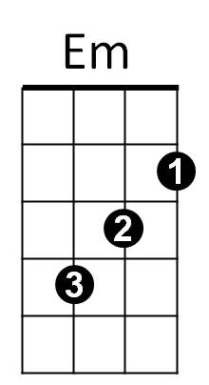

D
G
G7
BARITONE

G
Em
G7
D

