It’s a Jungle Out There (Randy Newman, 2003)
It’s A Jungle Out There by Randy Newman - Theme from Monk TV Show – Key of C

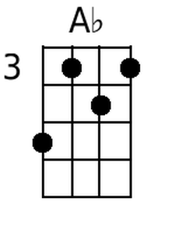  Intro: Cm G7 Cm G7  Cm D7  It is a jungle out there, disorder & con-fusion everywhere  Fm G7  No one seems to care Well I do!  Cm G7 Bbm7 C#º7 Fm  Hey, who´s in charge here? It’s a jungle out there  G7  Poison in the very air we breathe  Gm7 Bbm7  Do you know what´s in the water that you drink?  C#º7 Fm Gm7 B7 C#º7  Well I do, & it´s a- ma- zing (or sub D7)  Bbm7 C#º7  People think I am crazy, ´cause worry all the time  Fm C9 Fm  If you paid attention, you’d be worried too  G7  You better pay attention  G7 C Bb Ab C7  Or this world we love so much -- might just kill you  C7 C#º7 Caug C7  I could be wrong now, ___ but I don’t think so!  Fm C7 Fm  ´Cause it is a jungle out there  C7 Fm Gm7 Ab Gm7 Fm  It´s a jungle out there & Fm X888  Fm: Or tabs to Outro chords on  E STRING 1 3 4 3 1 Fm X888 |  |  |  |  |  | 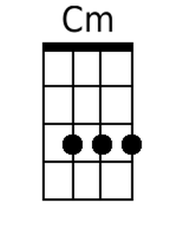 | 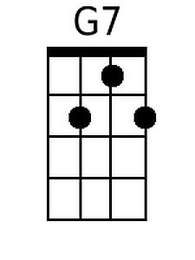 | 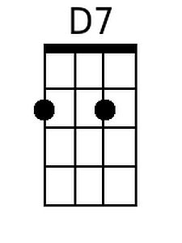
 |  |  |  |  |  | 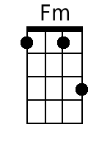 |  | 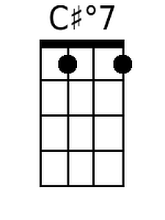
 |  |  |  |  |  | 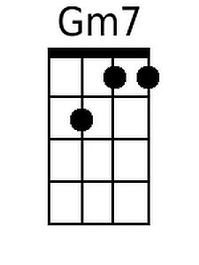 | 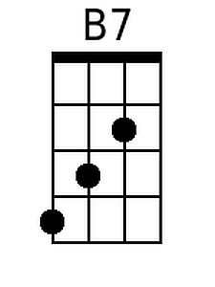 | 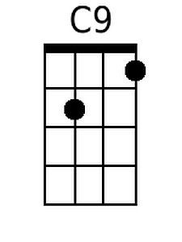
 |  |  |  |  |  | 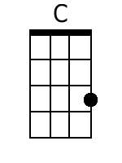 | 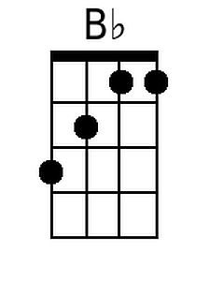
 |  |  |  |  |  | 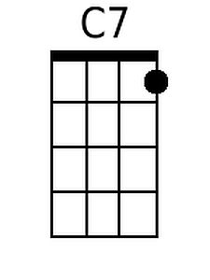 | 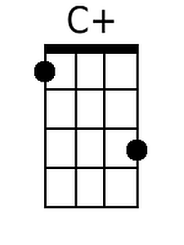 | 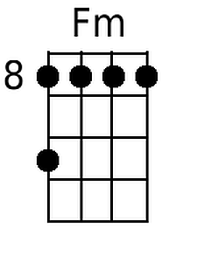
Baritone
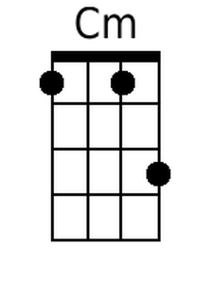 | 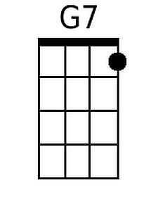 | 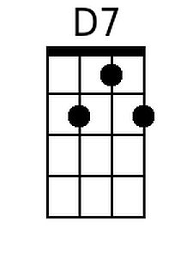 | 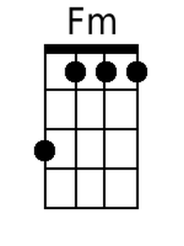 | 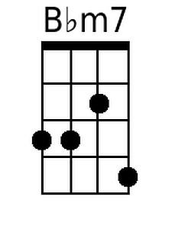 | 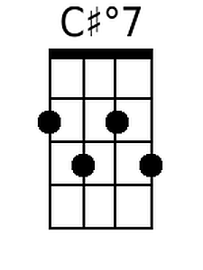 | 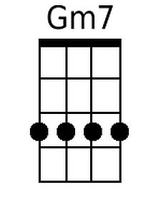
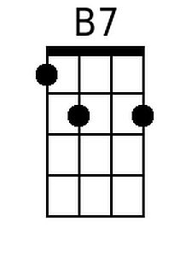 | 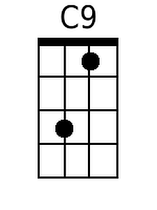 | 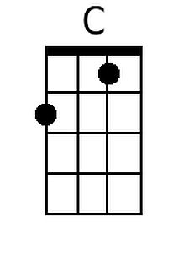 | 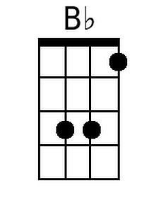 | 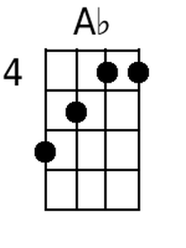 | 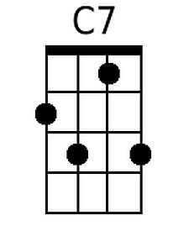 | 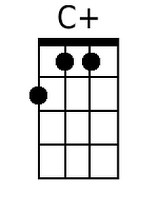

Cm X333  C#dim7 0101 | Cdim 2323 ?  Fm 1013 | Gm7 0211  Fm X888 | C9 0201  Caug 1003 | Bbm7 0111  Ab 5343

