It’s In His Kiss (Rudy Clark)

G (single strum) F (single strum)
Does he love me? I want to know
G (single strum)
How can I tell if he loves me so?

F G
(Is it in his eyes?) Oh no, you’ll be deceived
F G
(Is it in his eyes?) Oh no, he’ll make believe

C Am
If you want to know
(Shoop, shoop, shoop, shoop)
F G
If he loves you so
(Shoop, shoop, shoop, shoop)
C F G
It’s in his kiss (That’s where it is)

F G
(Or is it in his face?) Oh no, it's just his charms
F G
(In his warm embrace?) Oh no, that’s just his arms

C Am
If you want to know
(Shoop, shoop, shoop, shoop)
F G
If he loves you so
(Shoop, shoop, shoop, shoop)
C F G
It’s in his kiss (That’s where it is)
C F C
Oh, it’s in his kiss, that’s where it is

Reprise:
E7
Woah-oh-oh, hug him and squeeze him tight
Am
Find out what you want to know
D7 G

If it’s love, if it really is, it’s there in his kiss
F

G

F G
(About the way he acts) Oh no, thats not the way
F G
And you’re not listening to all I say

C Am
If you want to know
(Shoop, shoop, shoop, shoop)
F G
If he loves you so
(Shoop, shoop, shoop, shoop)
C F G
It’s in his kiss (That’s where it is)
C F C
Oh, it’s in his kiss, that’s where it is

(Repeat from Reprise, end chorus with G)

G C F G
Oh yeah, it’s in his kiss, that’s where it is

(Repeat to fade)
C F G


It’s in his kiss, that’s where it is
F
C
G

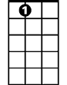


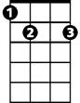
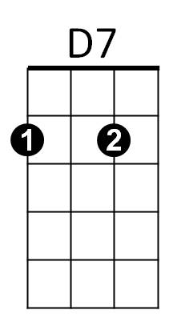
BARITONE
D7
E7
Am
C
Am
E7

