It's Raining Men (Paul Jabara / Paul Shaffer / Bob Esty)
Intro: Em G C B

Em
Humidity is rising - Barometer's getting low
According to our sources,


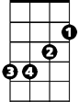

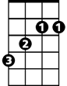
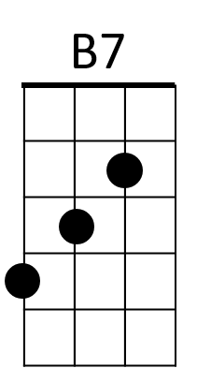
B7
D
C
Em
G
B
The street's the place to go
Em
Cause tonight for the first time
Am
Just about half -past ten
B
For the first time in history
B7
It's gonna start raining men.

C D
It's Raining Men! Hallelujah! –
B Em
It's Raining Men! Amen!
Am
I'm gonna go out to run and let myself get
B B7
Absolutely soaking wet!

C D
It's Raining Men! Hallelujah! –
B Em
It's Raining Men! Every Spe-ci-men!
Am
Tall, blonde, dark and lean
B B7
Rough and tough and strong and mean
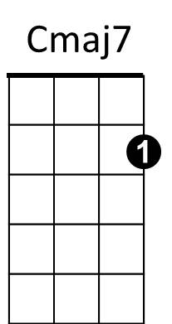

Am
Cmaj7 D
God bless Mother Nature,
B7 Em
She's a single woman too
Cmaj7 D
She took from the heavens
B7 Em
And she did what she had to do
Cmaj7 D B7 Em
She taught every angel to rearrange the sky

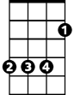
C
C
B
So that each and every woman
B7
Could find her perfect guy

C D
It's Raining Men! Hallelujah! –
B Em
It's Raining Men! Amen!
C D
It's Raining Men! Hallelujah! –
B Em D B7
It's Raining Men! A-me - e - en!

Em G C
I - feel storm-y wea-ther moving in
B
About to begin, about to begin
Em
Hear the thun-der
G C
Don't you lose your HEAD!
B
Rip off the roof and stay in bed

Cmaj7 D
God bless Mother Nature,
B7 Em
She's a single woman too
Cmaj7 D
She took from the heavens
B7 Em
And she did what she had to do
Cmaj7 D B7 Em
She taught every angel to rearrange the sky
C
So that each and every woman
B7
Could find her perfect guy
BARITONE
G
Em
(First Verse)

(4X)
C D
It's Raining Men! Hallelujah!
B Em
It's Raining Men! Amen!
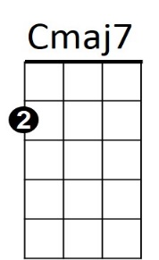

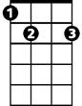
D
Am
B7

It's Raining Men (Paul Jabara / Paul Shaffer / Bob Esty)
Intro: Dm F Bb A

Dm
Humidity is rising - Barometer's getting low

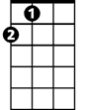


According to our sources,
Bb
Dm
F
A
A7
Gm
A7
The street's the place to go
Dm
Cause tonight for the first time
Gm
Just about half-past ten
A
For the first time in history
A7
It's gonna start raining men.

Bb C
It's Raining Men! Hallelujah! –
A Dm
It's Raining Men! Amen!
Gm
I'm gonna go out to run and let myself get
A A7
Absolutely soaking wet!

Bb C
It's Raining Men! Hallelujah! –
A Dm Am Dm
It's Raining Men! Every Spe – ci - men!
Gm
Tall, blonde, dark and lean
A A7
Rough and tough and strong and mean
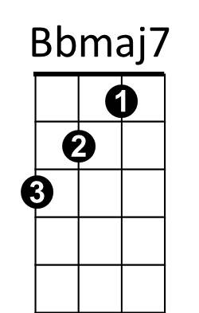
C
Bbmaj7 C
God bless Mother Nature,
A7 Dm
She's a single woman too
Bbmaj7 C
She took from the heavens
A7 Dm
And she did what she had to do
Bbmaj7 C A7 Dm
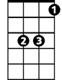
She taught every angel to rearrange the sky
Bb
A
Bb
So that each and every woman
A7
Could find her perfect guy

Bb C
It's Raining Men! Hallelujah! –
A Dm
It's Raining Men! Amen!
Bb C
It's Raining Men! Hallelujah! –
A Dm C A7
It's Raining Men! A-me – e - en!

Dm F Bb
I - feel storm - y weather moving in
A
About to begin, about to begin
Dm
Hear the thun-der
F Bb
Don't you lose your HEAD!
A
Rip off the roof and stay in bed

Bbmaj7 C
God bless Mother Nature,
A7 Dm
She's a single woman too
Bbmaj7 C
She took from the heavens
A7 Dm
And she did what she had to do
Bbmaj7 C A7 Dm
She taught every angel to rearrange the sky
Bb
So that each and every woman
A7
Could find her perfect guy
BARITONE
Dm
F
(First Verse)

(2X)
Bb C
It's Raining Men! Hallelujah!
A Dm
It's Raining Men! Amen!
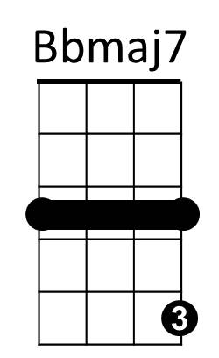
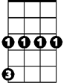
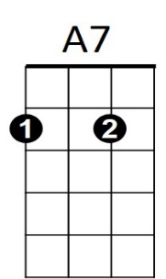
C
Gm

