Jingle Bell Rock (Bobby Helms)
C 25
Intro (Five Measures): F - Fm - F - G - C
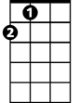


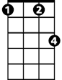

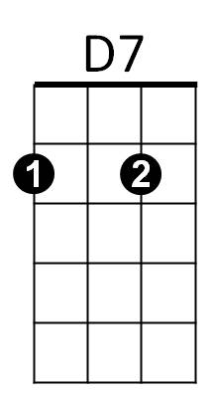

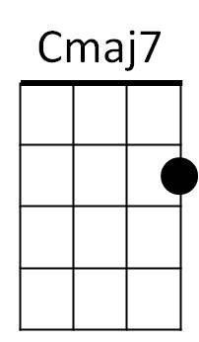
A
G
F
Fm
C
G7
C Cmaj7 C Cmaj7
Jingle bell, jingle bell, jingle bell rock,
C Cmaj7 F G7
Jingle bells swing and jingle bells ring,
G G7 G G7
Snowing and blowing up bushels of fun,
D7 G7
Now the jingle hop has begun.

C Cmaj7 C Cmaj7
Jingle bell, jingle bell, jingle bell rock,
C Cmaj7 F G7
Jingle bells chime in jingle bell time,
G G7 G G7 D7 G7 C C7
Dancing and prancing in Jingle Bell Square in the frosty air.
F Fm C C7
What a bright time, it's the right time to rock the night away,
D D7 G G7 G G7
Jingle bell time is a swell time - - - to go riding in a one-horse sleigh.

Reprise:

C Cmaj7 C Cmaj7 C Cmaj7 A
Giddy-up jingle horse, pick up your feet, jingle around the clock,
F Fm F G C G7
Mix and a-mingle in the jingling beat, that's the jingle bell rock.

(Repeat verses 1 & 2; No Reprise)

C Cmaj7 C Cmaj7 C Cmaj7 A
Giddy-up jingle horse, pick up your feet, jingle around the clock,
F Fm F G
Mix and a-mingle in the jingling beat, that's the jingle bell,
F G F G C C G7 C
That’s the jingle bell, that's the jingle bell rock.
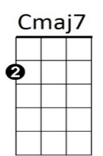

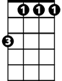


BARITONE
D7
G7
C
G
Fm
F
A

