
Jingle Bells
C10 C
(James Pierpont, 1857) – Jingle Bells by Bing Crosby and the Andrews Sisters (1943)

Intro (Last line of verse) F | C | G7 | C | G7  C F  Dashing through the snow, in a one-horse open sleigh,  G7 C  O'er the fields we go, laughing all the way,  F  Bells on bobtails ring, making spirits bright,  G7 C  What fun it is to ride and sing a sleighing song tonight.  Chorus  G7 C  Oh! Jingle bells, jingle bells, jingle all the way,  F C D7 G7  Oh what fun it is to ride in a one-horse open sleigh.  C  Hey! Jingle bells, jingle bells, jingle all the way,  F C G7 C  Oh what fun it is to ride in a one-horse open sleigh.  C F  A day or two ago, I thought I'd take a ride,  G7 C  And soon Miss Fanny Bright was seated by my side;  F  The horse was lean and lank, misfortune seemed his lot;  G7 C  He got into a drifted bank and then we got upsot. Chorus |  |  |  |  |  | 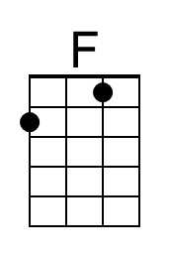
 |  |  |  |  |  | 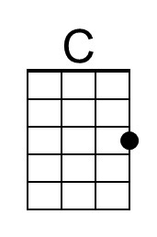
 |  |  |  |  |  | 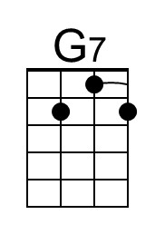
 |  |  |  |  |  | 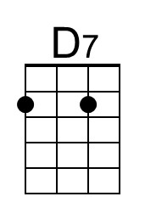
Baritone | 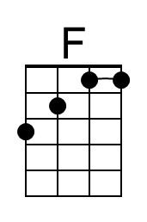 | 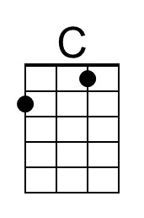 | 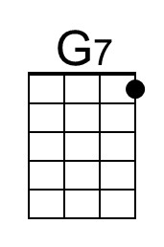 | 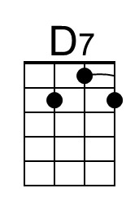

Jingle Bells
C10 G
(James Pierpont, 1857) – Jingle Bells by Bing Crosby and the Andrews Sisters (1943)

Intro (Last line of verse) C | G | D7 | G | D7

G C
Dashing through the snow, in a one-horse open sleigh,
D7 G
O'er the fields we go, laughing all the way,
C
Bells on bobtails ring, making spirits bright,
D7 G
What fun it is to ride and sing a sleighing song tonight.

Chorus
D7 G
Oh! Jingle bells, jingle bells, jingle all the way,
C G A7 D7
Oh what fun it is to ride in a one-horse open sleigh.
G
Hey! Jingle bells, jingle bells, jingle all the way,
C G D7 G
Oh what fun it is to ride in a one-horse open sleigh.

G C
A day or two ago, I thought I'd take a ride,
D7 G
And soon Miss Fanny Bright was seated by my side;
C
The horse was lean and lank, misfortune seemed his lot;
D7 G
He got into a drifted bank and then we got upsot. Chorus

 |  |  |  |  |  | 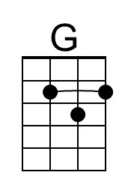
 |  |  |  |  |  | 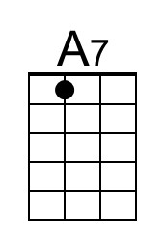
Baritone |  | 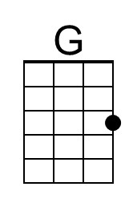 |  | 