


Johnny B. Goode (Chuck Berry, 1957) (C)

Intro: C F C G F C G  C  Deep down Louisiana close to New Orleans  Way back up in the woods among the evergreens  F  There stood a log cabin made of earth and wood  C  Where lived a country boy named Johnny B. Goode  G  Who never ever learned to read or write so well  C F C  But he could play the guitar just like a ringing a bell  Chorus:  C  Go go, Go Johnny go - Go, Go Johnny go  F C  Go, Go Johnny go - Go, Go Johnny go  G F C G  Go, Johnny B. Goode  Outro: C | G | C |  C  He used to carry his guitar in a gunny sack  Go sit beneath the tree by the railroad track  F  Oh, the engineers would see him sitting in the shade  C  Strumming with the rhythm that the drivers made  G  People passing by they would stop and say  C F C  Oh my that little country boy could play. Chorus  C  His mother told him "Someday you will be a man,  And you will be the leader of a big old band.  F  Many people coming from miles around  C  To hear you play your music when the sun go down  G  Maybe someday your name will be in lights  C F C  Saying Johnny B. Goode tonight." Chorus | 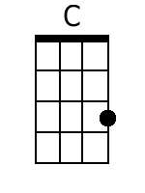
 | 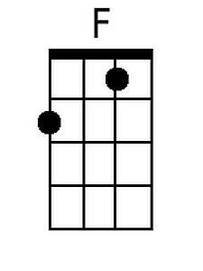
 | 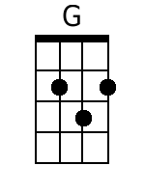
 | Bari
 | 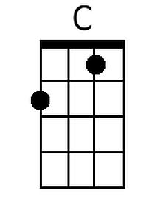
 | 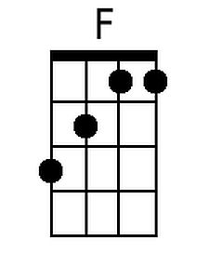
 | 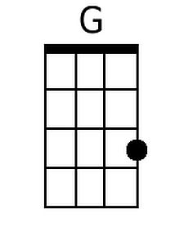

Johnny B. Goode (Chuck Berry, 1957) (G)

Intro: G C G D C G D

G
Deep down Louisiana close to New Orleans
Way back up in the woods among the evergreens
C
There stood a log cabin made of earth and wood
G
Where lived a country boy named Johnny B. Goode
D
Who never ever learned to read or write so well
G C G
But he could play the guitar just like a ringing a bell

Chorus:
G
Go go, Go Johnny go - Go, Go Johnny go
C G
Go, Go Johnny go - Go, Go Johnny go
D C G C
Go, Johnny B. Goode
Outro: G | C | G |
G
He used to carry his guitar in a gunny sack
Go sit beneath the tree by the railroad track
C
Oh, the engineers would see him sitting in the shade
G
Strumming with the rhythm that the drivers made
D
People passing by they would stop and say
G C G
Oh my that little country boy could play. Chorus

G
His mother told him "Someday you will be a man,
And you will be the leader of a big old band.
C
Many people coming from miles around
G
To hear you play your music when the sun go down
D
Maybe someday your name will be in lights
G C G
Saying Johnny B. Goode tonight." Chorus

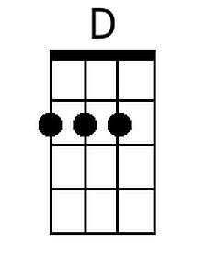
Bari
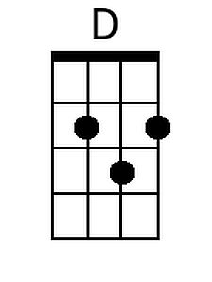

Johnny B. Goode (Chuck Berry, 1957) (NN)

Intro: 1 4 1 5 4 1 5  1  Deep down Louisiana close to New Orleans  Way back up in the woods among the evergreens  4  There stood a log cabin made of earth and wood  1  Where lived a country boy named Johnny B. Goode  5  Who never ever learned to read or write so well  1 4 1  But he could play the guitar just like a ringing a bell  Chorus:  1  Go go, Go Johnny go - Go, Go Johnny go  4 1  Go, Go Johnny go - Go, Go Johnny go  5 4 1 5  Go, Johnny B. Goode  Outro: 1 | 5 | 1 |  1  He used to carry his guitar in a gunny sack  Go sit beneath the tree by the railroad track  4  Oh, the engineers would see him sitting in the shade  1  Strumming with the rhythm that the drivers made  5  People passing by they would stop and say  1 4 1  Oh my that little country boy could play. Chorus  1  His mother told him "Someday you will be a man,  And you will be the leader of a big old band.  4  Many people coming from miles around  1  To hear you play your music when the sun go down  5  Maybe someday your name will be in lights  1 4 1  Saying Johnny B. Goode tonight." Chorus | 1 | 4 | 5
 | A | D | E
 | C | F | G
 | D | G | A
 | F | Bb | C
 | G | C | D

