Junk Food Junkie (Larry Groce)


C
C
You know I love that organic cooking,
F C
I always ask for more.
A7

And they call me Mr. Natural,
F
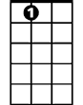
D7 G
A7
On down to the health food store.
C
I only eat good sea salt,
F C
White sugar don't touch my lips.
A7
And my friends are always begging me to take them
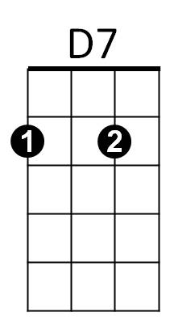
D G C Am
On macrobiotic trips, Yes, they are.
Am
Oh, but at night I take out my strongbox,
Dm Am


That I keep under lock and key.
G
Am

And I take it off to my closet,
B7 E7
Where nobody else can see.
Am

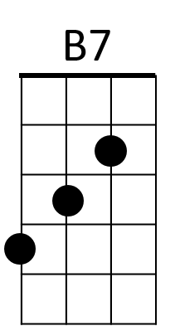
I open that door so slowly,
Dm
Dm Am
Take a peek up north and south.
C A7
Then I pull out a Hostess Twinkie,
D7 G C
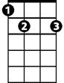
And I pop it in my mouth.
E7

CHORUS:
F C
Yeah, in the daytime I'm Mr. Natural,
G C
Just as healthy as I can be.
Am
But at night I'm a junk food junkie,
E7 Am
Good Lord have pity on me.

C
Well, at lunchtime you can always find me,
F C
At the Whole Earth Vitamin Bar.
A7
Just sucking on my plain white yogurt,
D7 G
From my hand thrown pottery jar.
C
And sippin' a little hand pressed cider,
F C
With a carrot stick for dessert.
A7
And wiping my face in a natural way,
D7 G C Am
On the sleeve of my peasant shirt. Oh yeah!
Am
Ah, but when that clock strikes midnight
Dm Am
And I'm all by myself.
B7 E7
I work that combination, on my secret hideaway shelf.
Am
BARITONE
And I pull out some Fritos co rn chips,
Dm Am
C
Dr. Pepper and an ol' Moon Pie.
C A7
Then I sit back in glorious expectation,
D7 G C
Of a genuine junk food high.

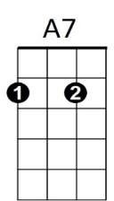
F
(CHORUS)

C
My friends down at the commune,

F C
D7
They think I'm pretty neat.
A7
Oh, I don't know nothing about arts and crafts,
D7 G
But I give 'em all something to eat.
C
G
I'm a friend to old Euell Gibbons,
F C
And I only eat homegrown spice.
A7
I got a John Keats autographed Grecian urn,
D7 G C Am
Am
Filled up with my brown rice. Yes, I do.
Am
Oh, but folks, lately I have been spotted,
Dm Am
With a Big Mac on my breath.

B7
Dm
Stumbling into a Colonel Sanders,
B7 E7
With a face as white as death.
Am
I'm afraid someday they'll find me,
E7
Dm Am
Just stretched out on my bed.
C A7
With a handful of Pringles Potato Chips,
D7 G C
And a Ding Dong by my head.

(CHORUS) (Last line slowly)

