Kokomo (John Phillips, Scott McKenzie, Mike Love, Terry Melcher, 1988) (C)
GCEA – Soprano, Concert & Tenor
Intro
C↓ F↓
Aruba, Jamaica, ooh, I want to take ya. Ber-muda, Bahama, come on, pretty mama.
C↓ F↓ C Cmaj
Key Largo, Montego, baby, why don't we go, Ja-maica. Off the Florida Keys,

Gm7 F Fm C D7 G
There's a place called Kokomo, that's where you want to go to get a-way from it all.
C Cmaj7 Gm7 F Fm C
Bodies in the sand, tropical drink melting in your hand. We'll be falling in love
D7 G C
To the rhythm of a steel drum band, down in Koko-mo.

Refrain
C F
A-ruba, Jamaica, ooh, I want to take you to Ber-muda, Bahama. Come on, pretty mama.
C Bb F
Key Largo, Montego, oo, I wan-na take you down to Kokomo?
ba-by, why don't we go?
Fm C
We'll get there fast and then we'll take it slow.
Am Dm7 G7 C
That's where we wanna go, way down in Koko-mo.
1. Martinique, that Montserrat mystique.
2. Port au Prince, I wanna catch a glimpse. To Bridge
3. (Repeat and fade)

C Cmaj7 Gm7 F
We'll put out to sea and we'll perfect our chemistry.
Fm C D7 - G C Cmaj7
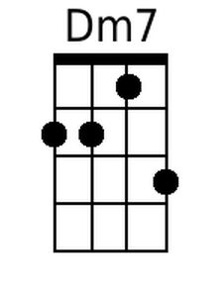
By and by we'll de-fy a little bit of gravity. | Afternoon de-light,
Gm7 F Fm C
cocktails and moonlit nights. That dreamy look in your eye,
D7 G C
Give me a tropical contact high way down in Koko-mo. Refrain

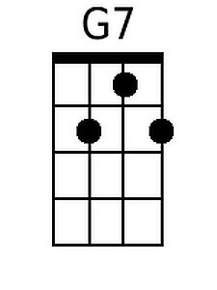
Bridge
C Cmaj7 Gm7 F Fm C
Everybody knows a little place like Kokomo. Now if you wanna go
D7 G7 C
and get a-way from it all, Go down to Koko-mo. Refrain

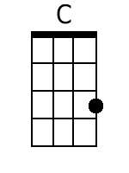 | 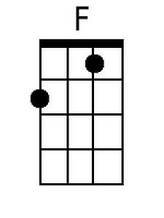 | 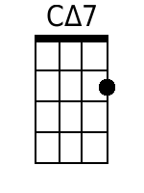 | 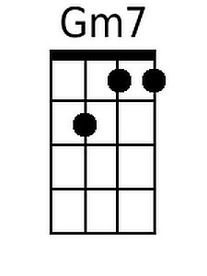 | 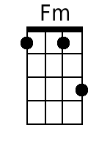 | 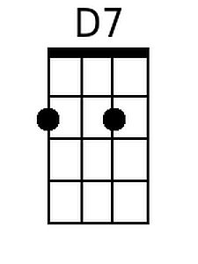 | 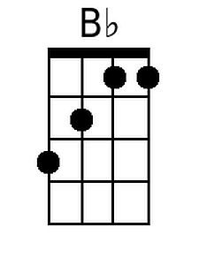 | 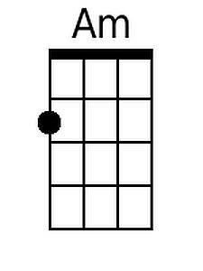

Kokomo (John Phillips, Scott McKenzie, Mike Love, Terry Melcher, 1988) (C)
DGBE – Baritone
Intro
C↓ F↓
Aruba, Jamaica, ooh, I want to take ya. Ber-muda, Bahama, come on, pretty mama.
C↓ F↓ C Cmaj
Key Largo, Montego, baby, why don't we go, Ja-maica. Off the Florida Keys,

Gm7 F Fm C D7 G
There's a place called Kokomo, that's where you want to go to get a-way from it all.
C Cmaj7 Gm7 F Fm C
Bodies in the sand, tropical drink melting in your hand. We'll be falling in love
D7 G C
To the rhythm of a steel drum band, down in Koko-mo.

Refrain
C F
A-ruba, Jamaica, ooh, I want to take you to Ber-muda, Bahama. Come on, pretty mama.
C Bb F
Key Largo, Montego, oo, I wan-na take you down to Kokomo?
ba-by, why don't we go?
Fm C
We'll get there fast and then we'll take it slow.
Am Dm7 G7 C
That's where we wanna go, way down in Koko-mo.
1. Martinique, that Montserrat mystique.
2. Port au Prince, I wanna catch a glimpse. To Bridge
3. (Repeat and fade)

C Cmaj7 Gm7 F
We'll put out to sea and we'll perfect our chemistry.
Fm C D7 - G C Cmaj7
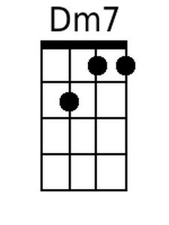
By and by we'll de-fy a little bit of gravity. | Afternoon de-light,
Gm7 F Fm C
cocktails and moonlit nights. That dreamy look in your eye,
D7 G C
Give me a tropical contact high way down in Koko-mo. Refrain

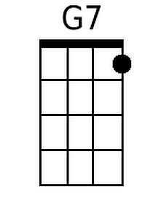
Bridge
C Cmaj7 Gm7 F Fm C
Everybody knows a little place like Kokomo. Now if you wanna go
D7 G7 C
and get a-way from it all, Go down to Koko-mo. Refrain

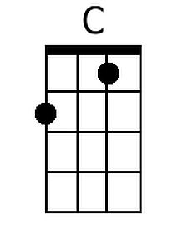 | 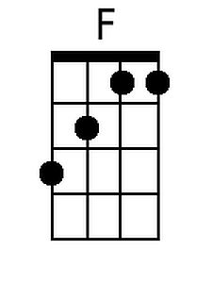 | 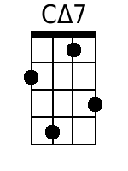 | 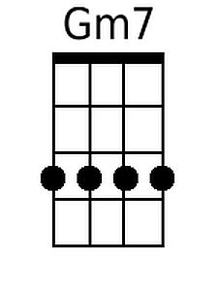 | 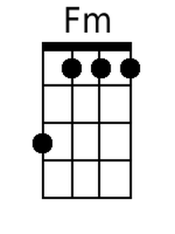 | 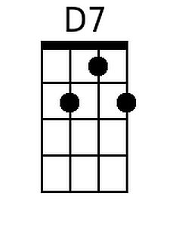 | 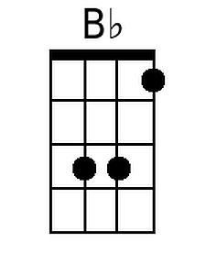 | 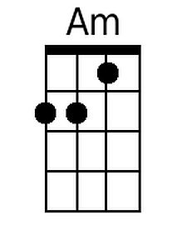

Kokomo (John Phillips, Scott McKenzie, Mike Love, Terry Melcher, 1988) (G)
GCEA – Soprano, Concert & Tenor
Intro
C↓ F↓
Aruba, Jamaica, ooh, I want to take ya. Ber-muda, Bahama, come on, pretty mama.
C↓ F↓ C Cmaj
Key Largo, Montego, baby, why don't we go, Ja-maica. Off the Florida Keys,

Dm7 C Cm G A7 D
There's a place called Kokomo, that's where you want to go to get a-way from it all.
G Gmaj7 Dm7 C Cm G
Bodies in the sand, tropical drink melting in your hand. We'll be falling in love
A7 D G
To the rhythm of a steel drum band, down in Koko-mo.

Refrain
G C
A-ruba, Jamaica, ooh, I want to take you to Ber-muda, Bahama. Come on, pretty mama.
G F C
Key Largo, Montego, oo, I wan-na take you down to Kokomo?
ba-by, why don't we go?
Cm G
We'll get there fast and then we'll take it slow.
Em Am7 D7 G
That's where we wanna go, way down in Koko-mo.
1. Martinique, that Montserrat mystique.
2. Port au Prince, I wanna catch a glimpse. To Bridge
3. (Repeat and fade)

G Gmaj7 Dm7 C
We'll put out to sea and we'll perfect our chemistry.
Cm G A7 - D G Gmaj7
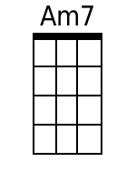
By and by we'll de-fy a little bit of gravity. | Afternoon de-light,
Dm7 C Cm G
cocktails and moonlit nights. That dreamy look in your eye,
A7 D G
Give me a tropical contact high way down in Koko-mo. Refrain
Bridge
G Gmaj7 Dm7 C Cm G
Everybody knows a little place like Kokomo. Now if you wanna go
A7 D7 G
and get a-way from it all, Go down to Koko-mo. Refrain

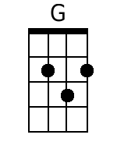 |  | 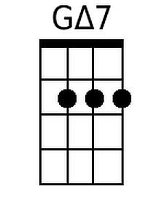 |  | 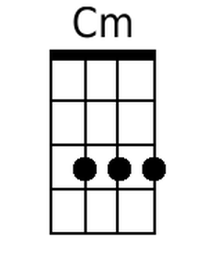 | 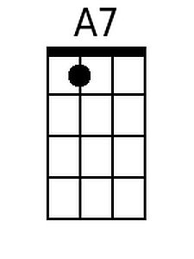 |  | 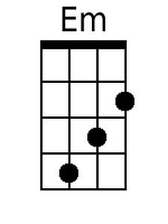

Kokomo (John Phillips, Scott McKenzie, Mike Love, Terry Melcher, 1988) (G)
DGBE – Baritone
Intro
C↓ F↓
Aruba, Jamaica, ooh, I want to take ya. Ber-muda, Bahama, come on, pretty mama.
C↓ F↓ C Cmaj
Key Largo, Montego, baby, why don't we go, Ja-maica. Off the Florida Keys,

Dm7 C Cm G A7 D
There's a place called Kokomo, that's where you want to go to get a-way from it all.
G Gmaj7 Dm7 C Cm G
Bodies in the sand, tropical drink melting in your hand. We'll be falling in love
A7 D G
To the rhythm of a steel drum band, down in Koko-mo.

Refrain
G C
A-ruba, Jamaica, ooh, I want to take you to Ber-muda, Bahama. Come on, pretty mama.
G F C
Key Largo, Montego, oo, I wan-na take you down to Kokomo?
ba-by, why don't we go?
Cm G
We'll get there fast and then we'll take it slow.
Em Am7 D7 G
That's where we wanna go, way down in Koko-mo.
1. Martinique, that Montserrat mystique.
2. Port au Prince, I wanna catch a glimpse. To Bridge
3. (Repeat and fade)

G Gmaj7 Dm7 C
We'll put out to sea and we'll perfect our chemistry.
Cm G A7 - D G Gmaj7
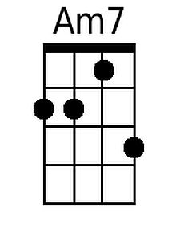
By and by we'll de-fy a little bit of gravity. | Afternoon de-light,
Dm7 C Cm G
cocktails and moonlit nights. That dreamy look in your eye,
A7 D G
Give me a tropical contact high way down in Koko-mo. Refrain

Bridge
G Gmaj7 Dm7 C Cm G
Everybody knows a little place like Kokomo. Now if you wanna go
A7 D7 G
and get a-way from it all, Go down to Koko-mo. Refrain

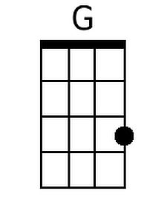 |  | 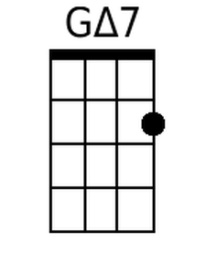 |  | 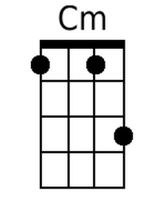 | 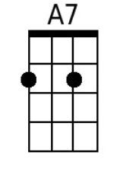 |  | 