L-O-V-E (Milt Gabler / Ben Kaempfert) Key C


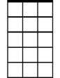
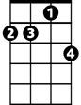
C Am7 Dm7 G7
C
Am7
Dm7
L - is for the way you look at me
Dm7 G7 C
O - is for the only one I see
C7 F



V - is very, very, extraordinary
G7
C7
D
D D7 G D7 G7
E - is even more than any-one that you adore

C Am7 Dm7 G7
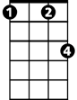


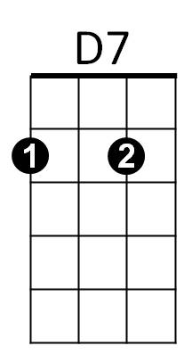
Love is all that I can give to you
Fm
F
G
Dm7 G7 C
Love is more than just a game for two
C7
Two in love can make it -
F Fm
Take my heart, and please don’t break it
C G C G
Love was made for me and you

Repeat song play G
BARITONE
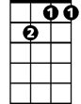
Dm7
Am7
C
C7
Two in love can make it -
F Fm
Take my heart, and please don’t break it

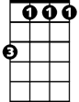
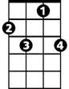
C G C
D7
F
Fm
G
C7
G7
D
Love was made for me and you

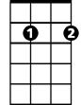
L-O-V-E (Milt Gabler / Ben Kaempfert) Key G
Em7
Am7
G
BARITONE
G Em7 Am7 D7
L is for the way you look at me
Am7 D7 G
O is for the only one I see
G7 C
C
G7
V is very, very extraordinary
A A7 D A7 D7
E is even more than any one that you adore can

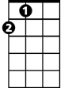
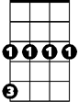
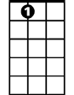
G Em7 Am7 D7
A
Cm
D
A7
Love is all that I can give to you
Am7 D7 G
Love is more than just a game for two
G7
Two in love can make it
C Cm
Take my heart and please don’t break it
G D7 G D
Love was made for me and you

Repeat song
Em7
Am7
G
G7
Two in love can make it
C Cm
Take my heart and please don’t break it
G D7 G D
C
D7
G7
Love was made for me and you

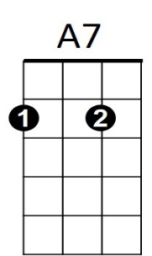
A
Cm
D

