Laurie (Strange Things Happen in this World) (Milton Addington)



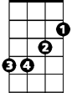
C
G
F
Em
C Am F G
Last night at the dance I met Laurie,
C Em F G
So lovely and warm, an ange l of a girl.
C C7 F Fm
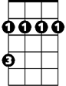



Last night I fell in love with Laurie -
Bm
Dm
Am
C7
C Am Dm F G
Strange things happen in this world.

C Am F G
As I walked her home, she said it was her birthday.
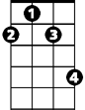
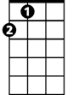
C Em F G
F#m
A

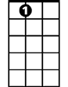
I pulled her close and said, "Will I see you anymore?"
D
A7
C C7 F Fm
Then suddenly she asked for my sweater
C Am Dm G C C7
And said that she was very, very cold.

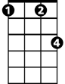
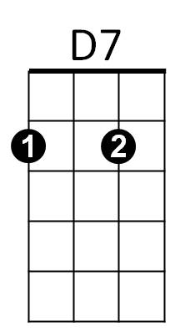

F C C7
Fm
Gm
I kissed her good n ight at her door and started home,
F C C7
T hen thought about my sweater and went right back instead.
F C Am
I knocked at her door and a man appeared.
D7 F G
I told why I'd come, then he said:
BARITONE

G
C
F
Em
C Am F G
"You're wrong, son, you weren't with my daughter.
C Em F G
How can you be so cruel to come to me this way?
C C7 F Fm
My Laurie left this world on her birthday -
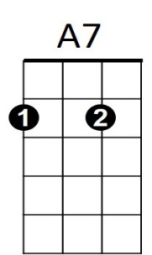
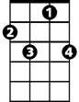
C Am Dm Em A7
Bm
C7
Am
Dm
She died a year ago today."

D Bm G A
A strange force drew me to the graveyard.
D F#m G A
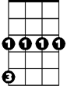

I stood in the dark, I saw the shadows wave,
Gm
D7
F#m
A
D
D D7 G Gm
And then I looked and saw my sweater
D G D D7
Lyin' there upon her grave.
G A G D
Strange things happen in this - world.

