Let It Snow (Sammy Cahn/Julie Styne)
C 32





C G7 C
C
G
G7
Dm
Oh, the weather outside is frightful
Dm G
But the fire is so delightful
Dm A7 Dm
And since we’ve no place to go
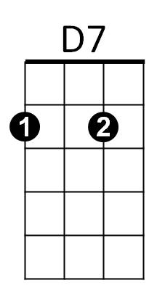
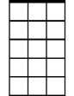
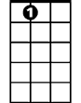
G7 C G G7 C
Am7
A7
Let it snow, let it snow, let it snow

C G7 C
It doesn’t show signs of stopping
Dm G
And I’ve brought some corn for popping
Dm A7 Dm
The lights are turned way down low
G7 C G G7 C
Let it snow, let it snow, let it snow

Chorus:
G7 Am7 D7 G
When we finally kiss goodnight, how I’ll hate going out in the storm
A7 D7 G G7
But if you’ll really hold me tight, all the way home I’ll be warm
BARITONE



C G7 C
G
Dm
G7
C
The fire is slowly dying
Dm G
And my dear, we’re still good-bye-ing
Dm A7 Dm
As long as you love me so
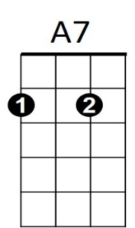
G7 C G G7 C
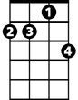
Let it snow, let it snow, let it snow. Chorus
D7
Am7

C G7 C
The fire is slowly dying
Dm G
And my dear, we’re still good-bye-ing
Dm A7 Dm
As long as you love me so
G7 A7 (Pause)
Let it snow, let it snow, let it snow-
G7 C G G7 C
Let it snow, let it snow, let it snow

