Let it Be Me (Gilbert Becaud / Pierre Delanoe)

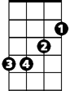C G7
Em
Am
G7
C
I bless the day I found you
Am Em
I want to stay around you
F C
And so I beg you
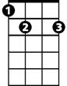F G7
E7
C7
F
Let it be me

C G7
Don't take this heaven from one
Am Em
If you must cling to someone
F C
Now and forever
F C C7
Let it be me

Reprise:

F Em
Each time we meet love
F C
I find complete love
BARITONE
Am Em
G7
Em
Am
C
Without your sweet love
F E7 G7
What would life be

C G7
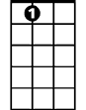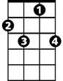So never ever leave me lonely
E7
C7
F
Am Em
Tell me you love me only
F C
And that you'll always
F C C7
Let it be me

(Reprise and last verse; play last line slowly)

