Levon (Elton John / Bernie Taupin) Key C
Intro: C F (4X)
C F C
Levon wears his war wound like a crown.
F C
He calls his child Jesus -
G Am
`Cause he likes the name
Em7 F Dm
And he sends him to the finest school in town

C F C
And Levon, Levon likes his money
F C
He makes a lot they say -
G Am
Spends his days counting
Em7 F Dm
In a garage by the mo-torway

Reprise:
Em7 Am
He was born a pauper to a pawn
F
On a Christmas day
C Dm
When the New York Times said God is dead
C


And the war's begun
F
C
F C Dm
Alvin Tostig has a son today

Chorus:
TACET F
And he shall be Levon
C
And he shall be a good man
BARITONE
F
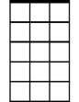



And he shall be Levon
Em7
G
Dm
Am
F
C
C
In tradition with the family plan
F
And he shall be Levon
C
and he shall be a good man
F G
He shall be Le - von
C F C F

C F C
Levon sells cartoon balloons in town
F C
His family business thrives –
G Am
Jesus blows up balloons all day
Em7 F Dm
Sits on the porch swing watching them fly

C F C
And Jesus, he wants to go to Venus
F C
Leaving Levon far behind -
G Am
Take a balloon and go sailing
Em7 F Dm
While Levon, Le von slowly dies

(Reprise)

(Chorus) 2x

C F C F (repeat to fade)



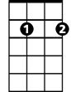
G
Am
Em7
Dm

Levon (Elton John / Bernie Taupin) Key F
Intro: F Bb (4X)
F Bb F
Levon wears his war wound like a crown.
Bb F
He calls his child Jesus -
C Dm
`Cause he likes the name
Am7 Bb Gm
And he sends him to the finest school in town

F Bb F
And Levon, Levon likes his money
Bb F
He makes a lot they say -
C Dm
Spends his days counting
Am7 Bb Gm
In a garage by the mo-torway

Reprise:
Am7 Dm
He was born a pauper to a pawn
Bb
On a Christmas day
F Gm
When the New York Times said God is dead
F
And the war's begun
Bb
Bb F Gm
Alvin Tostig has a son today

Chorus:
TACET Bb
And he shall be Levon
F
And he shall be a good man
BARITONE
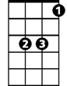
Bb
Bb
F
And he shall be Levon
F
In tradition with the family plan
Bb
And he shall be Levon
F
and he shall be a good man
Bb C
He shall be Le - von
F Bb F Bb

F Bb F
Levon sells cartoon balloons in town
Bb F
His family business thrives –
C Dm
Jesus blows up balloons all day
Am7 Bb Gm
Sits on the porch swing watching them fly

F Bb F
And Jesus, he wants to go to Venus
Bb F
Leaving Levon far behind -
C Dm
Take a balloon and go sailing
Am7 Bb Gm
While Levon, Le von slowly dies

(Reprise)

(Chorus) 2x

F Bb F Bb (repeat to fade)

C
Dm
Am7
F
Gm

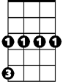
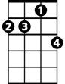
Gm
Am7
Dm
C

Levon (Elton John / Bernie Taupin) Key G
Intro: G C (4X)
G C G
Levon wears his war wound like a crown.
C G
He calls his child Jesus -
D Em
`Cause he likes the name
Bm7 C Am
And he sends him to the finest school in town
G C G
And Levon, Levon likes his money
C G
He makes a lot they say -
D Em
Spends his days counting
Bm7 C Am
In a garage by the mo-torway

Reprise:
Bm7 Em
He was born a pauper to a pawn
C
On a Christmas day
G Am
When the New York Times said God is dead
G
And the war's begun
C
G
C G Am
Alvin Tostig has a son today

Chorus:
TACET C
And he shall be Levon
G
And he shall be a good man
BARITONE
C
And he shall be Levon
G
C
G
In tradition with the family plan
C
And he shall be Levon
G
and he shall be a good man
C D
He shall be Le – von
G C G C

G C G
Levon sells cartoon balloons in town
C G
His family business thrives –
D Em
Jesus blows up balloons all day
Bm7 C Am
Sits on the porch swing watching them fly

G C G
And Jesus, he wants to go to Venus
C G
Leaving Levon far behind -
D Em
Take a balloon and go sailing
Bm7 C Am
While Levon, Le von slowly dies

(Reprise)

(Chorus) 2x

G C G C (repeat to fade)


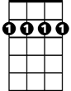
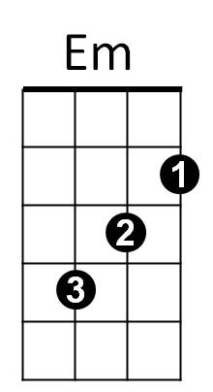
D
Bm7
Am
Em
Bm7
Am
D

