Light My Fire (Van Morrison)

Intro: F Em C Am / F Em C Am / F Em Asus4 A
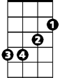

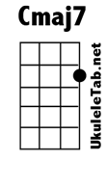
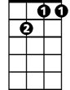
Em
F
Cmaj7
Gm7
Gm7 Cmaj7
You know that it would be untrue
Gm7 Cmaj7
You know that I would be a liar
Gm7 Cmaj7
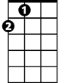
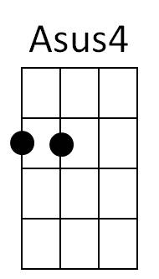


If I were to say to you
A
Am
C
Gm7 Cmaj7
Girl, we couldn't get much higher

Chorus

F Em C Am
Come on baby light my fire
F Em C Am
Come on baby light my fire
F Em Asus4 A
BARITONE
Try to set the night on fire

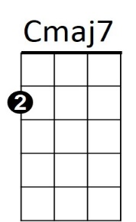
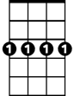
F
Em
Gm7
Gm7 Cmaj7
The time to hesitate is through
Gm7 Cmaj7
No time to wallow in the mire
Gm7 Cmaj7

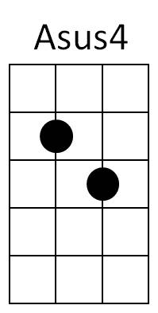

Try now we can only lose
A
Am
C
Gm7 Cmaj7
And our love become a funeral pyre

(Chorus)

Repeat entire song
Outro:
F Em Asus4 A
Try to set the night on fire (Repeat to fade)

