Little Saint Nick
C121 C
(Brian Wilson and Mike Love, 1963) – Little Saint Nick by The Beach Boys (F#)
Little Saint Nick by The Beach Boys (Televised, 1960s)

Intro | C F C F | C F C F |
Dm7 C C Dm7 G7
Ooo-ooo. Merry Christmas, Saint Nick. (Christmas comes this time each year). Ooo – ooo.

Dm7 G7 Dm7 G7 C
Well way up north where the air gets cold, there's a tale about Christmas
C#dim7 Dm7 G7 Dm7 G7
That you've all been told. And a real famous cat all dressed up in red
C C#dim7
All he spends all year workin' out on his sled
F Dm7 G7
It's the little Saint Nick. (Little Saint Nick). It's the little Saint Nick (Little Saint Nick).

Dm7 G7 Dm7 G7 C C#dim7
Just a little bob-sled we call the old Saint Nick, But she'll walk a toboggan with a four speed stick
Dm7 G7 Dm7 G7 C C#dim7
She's candy apple red with a ski for a wheel, And when Santa hits the gas man just watch her peel.
F Dm7 G7
It's the little Saint Nick. (Little Saint Nick). It's the little Saint Nick (Little Saint Nick).

Bridge
F Bb F D
Run run reindeer, Run run reindeer, Run run reindeer, Run run reindeer.
Tacet He don't miss no one.

Dm7 G7 Dm7 G7 C C#dim7
And haulin' through the snow at a frightening speed with a half a dozen deer with Rudy to lead
Dm7 G7 Dm G7
He's got to wear his goggles cause the snow really flies,
C C#dim7
And he's cruisin' every pad with a little surprise.
F C C#dim7
It's the little Saint Nick. (Little Saint Nick). It's the little Saint Nick. (Little Saint Nick)

Outro
Dm7 G7 Dm7 G7 C C#dim7
Ooo - ooo, Merry Christmas, Saint Nick. (Christmas comes this time each year) (3x)
Dm7 G7 C
Merry Christmas Reindeer.

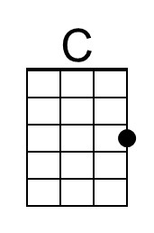 | 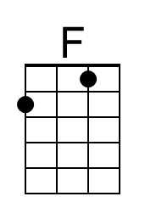 | 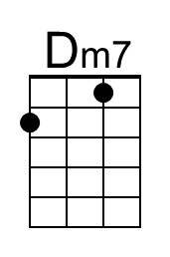 | 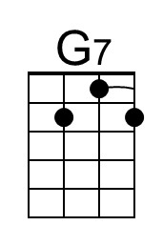 | 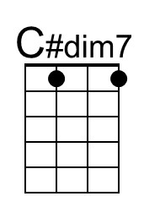 | 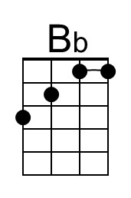 | 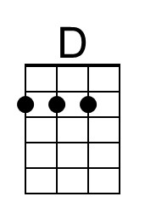
Baritone | 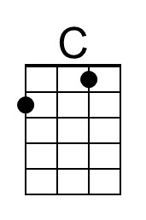 | 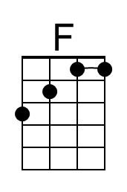 | 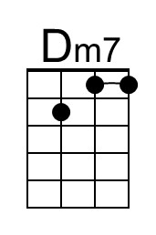 | 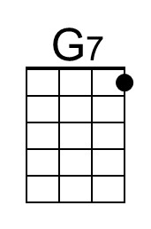 | 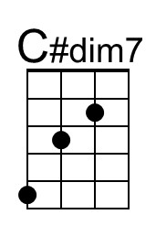 | 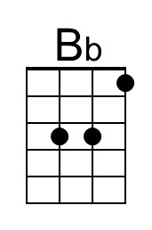 | 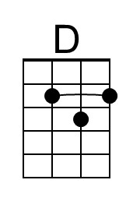

Little Saint Nick
C121 G
(Brian Wilson and Mike Love, 1963) – Little Saint Nick by The Beach Boys (F#)
Little Saint Nick by The Beach Boys (Televised, 1960s)

Intro | G C G C | G C G C |
Am7 G G Am7 D7
Ooo-ooo. Merry Christmas, Saint Nick. (Christmas comes this time each year). Ooo – ooo.

Am7 D7 Am7 D7 G
Well way up north where the air gets cold, there's a tale about Christmas
G#dim7 Am7 D7 Am7 D7
That you've all been told. And a real famous cat all dressed up in red
G G#dim7
All he spends all year workin' out on his sled
C Am7 D7
It's the little Saint Nick. (Little Saint Nick). It's the little Saint Nick (Little Saint Nick).

Am7 D7 Am7 D7 G G#dim7
Just a little bob-sled we call the old Saint Nick, But she'll walk a toboggan with a four speed stick
Am7 D7 Am D7 G G#dim7
She's candy apple red with a ski for a wheel, And when Santa hits the gas man just watch her peel.
C Am7 D7
It's the little Saint Nick. (Little Saint Nick). It's the little Saint Nick (Little Saint Nick).

Bridge
C F C A
Run run reindeer, Run run reindeer, Run run reindeer, Run run reindeer.
Tacet He don't miss no one.

Am7 D7 Am7 D7 G G#dim7
And haulin' through the snow at a frightening speed with a half a dozen deer with Rudy to lead
Am7 D7 Am D7
He's got to wear his goggles cause the snow really flies,
G G#dim7
And he's cruisin' every pad with a little sur-prise.
C G G#dim7
It's the little Saint Nick. (Little Saint Nick). It's the little Saint Nick. (Little Saint Nick)

Outro
Am7 D7 Am7 D7 G G#dim7
Ooo - ooo, Merry Christmas, Saint Nick. (Christmas comes this time each year) (3x)
Am7 D7 G
Merry Christmas Reindeer.

 | 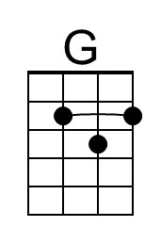 | 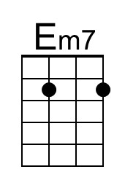 | 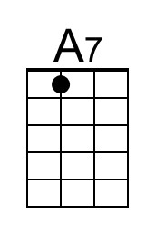 | 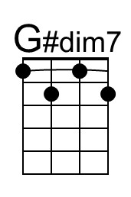 |  | 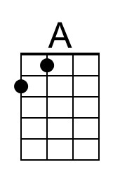
Baritone |  | 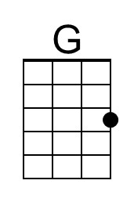 | 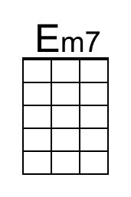 | 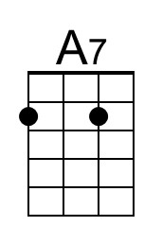 | 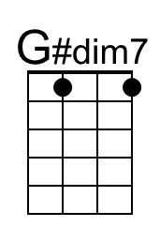 |  | 