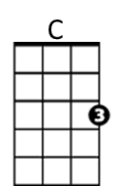
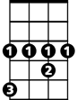Lola (Ray Davies)
Ab
Bb
Intro: Ab Bb C

C
I met her in a club down in old Soho
F Bb
Where you drink champagne and it tastes just like
C F Fsus4 F
coca cola - C-O-L-A, c ola
C
She walked up to me and she asked me to dance
F Bb
I asked her her name and in a dark brown voice
C
She said “Lola”
F Bb Ab Bb C
L-O-L-A, Lola, Lo lo lo lo lola

C
Well I'm not the world’s most physical guy
F
but when she squeezed me tight
Bb C
she nearly broke my spine, oh my Lola
F Fsus4 F
Lo lo lo lo Lola

C
Well I'm not dumb but I can't understand
F Bb
why she walked like a woman and talked like a man
C
oh my Lola
F Bb Ab Bb C
Lo lo lo lo Lola Lo lo lo lo Lola

G7
Well we drank champagne and danced all night
D
under electric candlelight
F
She picked me up and sat me on her knee
and said 'Dear boy, won't you come home with me'

C
Well I'm not the world's most passionate guy
F
But when I looked in her eye,
Bb C
Well I almost fell for my Lola
F Bb Ab Ab Bb
Lo lo lo lo Lola Lo lo lo lo Lola
C F Bb Ab Ab Bb C
Lola, Lo lo lo lo Lola, lo lo lo lo Lola

F C G7
I pushed her away
F C G7
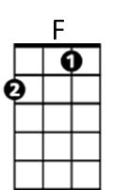
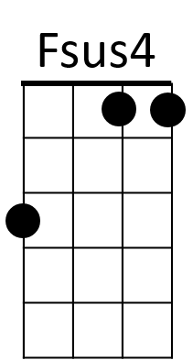
I walked to the door
F C G7
I fell to the floor
C Em Am
I got down on my knees
 G7
G7
Then I looked at her and she at me

C
Well that's the way that I want it to stay
F Bb C
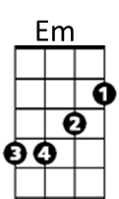
and I always want it to be that way for my Lola
F Fsus4 F
Lo lo lo lo Lola
C
Girls will be boys and boys will be girls
F Bb
It's a mixed up, muddled up, shook up world except
Am
C F
for Lola - Lo lo lo lo Lola

G7
Well I left home just a week before
D
And I'd never ever kissed a woman before
F
Lola smiled and took me by the hand
and said 'Dear boy, I'm gonna make you a man'

C
Well I'm not the world’s most passionate man
F Bb
But I know what I am and what I am is a man
C F Bb Ab Ab Bb
and so is Lola, lo lo lo lo lola Lo lo lo lo Lola

(3X – end C)
C F Bb Ab Ab Bb
Lola, lo lo lo lo Lola, lo lo lo lo Lola
BARITONE
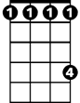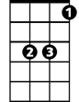
Ab
C
Bb
F

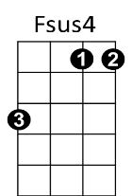

Em
Am
G7

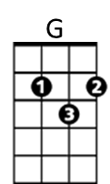
Lola (Ray Davies)
Intro: Eb F G

G
I met her in a club down in old Soho
C F
Where you drink champagne and it tastes just like
G
coca cola
C Csus4 C
C-O-L-A, cola
G
She walked up to me and she asked me to dance
C F
I asked her her name and in a dark brown voice she
G
said “Lola”
C F Eb F G
L-O-L-A, Lola, Lo lo lo lo lola

G
Well I'm not the world’s most physical guy
C
but when she squeezed me tight
F G
she nearly broke my spine, oh my Lola
C Csus4 C
Lo lo lo lo Lola

G
Well I'm not dumb but I can't understand
C F
why she walked like a woman and talked like a man
G
oh my Lola
C F Eb F G
Lo lo lo lo Lola Lo lo lo lo Lola

D7
Well we drank champagne and danced all night
A
under electric candlelight
C
She picked me up and sat me on her knee
and said 'Dear boy, won't you come home with me'

G
Well I'm not the world's most passionate guy
C
But when I looked in her eye,
F G
Well I almost fell for my Lola
C F Eb Eb F
Lo lo lo lo Lola Lo lo lo lo Lola
G C F Eb Eb F G
Lola, Lo lo lo lo Lola, lo lo lo lo Lola

C G D7
I pushed her away
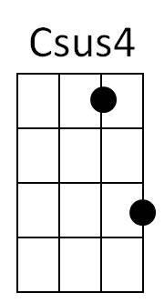
C G D7
I walked to the door
C G D7
I fell to the floor
G Bm Em
I got down on my knees
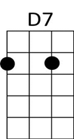
D7
Then I looked at her and she at me

G
Well that's the way that I want it to stay
C F G
and I always want it to be that way for my Lola
C Csus4 C
Lo lo lo lo Lola
G
Girls will be boys and boys will be girls
C F
It's a mixed up, muddled up, shook up world except
G C
for Lola- Lo lo lo lo Lola

D7
Well I left home just a week before
A
And I'd never ever kissed a woman before
C
Lola smiled and took me by the hand
and said 'dear boy, I'm gonna make you a man'

G
Well I'm not the world’s most passionate man
C F
But I know what I am and what I am is a man
G C F Eb Eb F
and so is Lola, lo lo lo lo lola Lo lo lo lo Lola

G C F Eb Eb F (3x, end G)
Lola, lo lo lo lo Lola, lo lo lo lo Lola
BARITONE
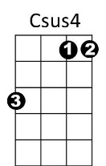

G
F
C

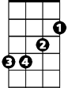
D7
Eb
Bm
Em

