Lonely People (Dan Peek)

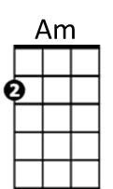
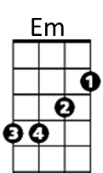
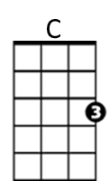
Intro: C Am Em C Am Em F G C Am F G C G

C Am Em
This is for all the lonely people,
C Am Em
Thinking that life has passed them by
F G C Am
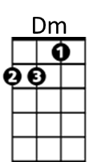
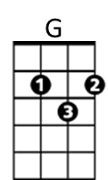
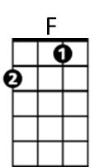
Don't give up until you drink from the silver cup,
F G C G
And ride that highway in the sky

C Am Em
This is for all the single people,
C Am Em
Thinking that love has left them dry
F G C Am
Don't give up until you drink from the silver cup,
F G C G
You never know until you try

F C Dm
Well, I'm on my way
F C Dm
Yes, I'm back to stay
F C Dm G C G
Well, I'm on my way back home (Hit it)

C Am Em C Am Em F G C Am F G C G

C Am Em
This is for all the lonely people,
C Am Em
Thinking that life has passed them by
F G C Am
Don't give up until you drink from the silver cup,
F G C Am
She’ll never take you down, or never give you up,
F G Am
You never know until you try

