Long, Long Time (Gary White)



G
F
Am
F G Am F G C
Love will abide. Take things in stride.
F G7 Am D7 G
Sounds like good advice, but there's no one at my side;
F G Am F G C
And time washes clean love's wounds unseen;

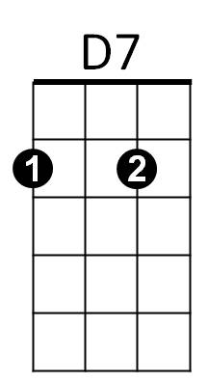

F G7 Am D7 G7
G7
C
That's what someone told me, but I don't know what it means.

F G7 C Am F
‘Cause I've done everything I know to try and make you mine,
C G Am F C G C
And I think I'm gonna love you for a long, long tim e.

F G Am F G C
Caught in my fears, blinking back the tears;
F G7 Am D7 G
I can't say you hurt me when you never let me near.
F G Am F G C
And I never drew one response from you,
BARITONE
F G7 Am D7 G7


All the while you fell over girls you never knew.
F
Am
G

F G7 C Am F
‘Cause I've done everything I know to try and make you mine,
C G Am F C G C
And I think I'm gonna love you for a long, long time.


D7
G7
C
F G Am F G C
Wait for the day ~ you go away,
F G7 Am D7 G
Knowing that you warned me of the price I'd have to pay;
F G Am F G C
And life's full of loss, who knows the cost,
F G7 Am D7 G7
Living in the mem - o - ry of the love that never was.

F G7 C Am F
Cause I've done everything I know to try and change your mind,
C G Am F G C
And I think I'm gonna miss you for a long, long time.

F G C C7 F Am
'Cause I've done everything I know to try and make you mine,
C G Am F C G C
And I think I'm gonna love you for a long, long time.

