Makin' Whoopee (Gus Kahn & Walter Donaldson)

C Am Dm G7
Another bride, another June
C C7 F Fm
Another sunny honeymoon
C Am Dm G7
Another season, another reason
C Cdim Dm G7
For maki n' whoopee

C Am Dm G7
You get some shoes, a little rice
C C7 F Fm
The groom's so nervous he answers twice
C Am Dm G7
It's really thrillin' that he's so willin'
C F Fm7 C
For makin' whoopee

C7 Dm
Picture a little love nest
Dm C
Down where the roses cling
C7 Dm
Picture that same love nest
Dm G7
And see what a year will bring

C Am Dm G7
He's doin' dishes and baby clothes
C C7 F Fm
He's so ambitious, he even sews
C Am Dm G7
Just don't forget, folks, that's what you get, folks,
C Cdim Dm G7
For makin' whoopee

C Am Dm G7
Another year or maybe less
C C7 F Fm
What's this I hear? Well, can't you guess?
C Am Dm G7
She feels neglected and he's suspected
C Cdim Dm G7
Of makin' whoopee
BARITONE
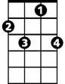




C7
G7
Dm
Am
C

C Am Dm G7
She sits alone 'most every night
C C7 F Fm
He doesn't phone her, he doesn't write
C Am Dm G7
He says he's "busy" but she says "is he?"
C F Fm7 C
He's makin' whoopee

C7 Dm
He doesn't make much money
Dm C
Only a five-thousand per
C7 Dm
Some judge who thinks he's funny
Dm G7
Told him he got to pay six to her

C Am Dm G7
He says: "Now judge, suppose I fail."
C C7 F Fm
The judge says: "Budge right into jail!
C Am Dm G7
You'd better keep her I think it's cheaper
C Cdim Dm G7
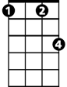
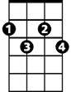
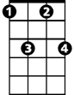
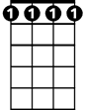
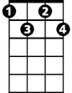
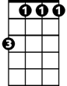

Than makin' whoopee
F
Fm
Cdim
Fm7
Fm7
Cdim
Fm
F
C Am Dm G7
Just don't forget, folks, that's what you get, folks,
C F Fm7 C



For makin' whoopee
Dm
G7
C7
C
Am

