Manuela Boy (Johnny Moore)
VAMP: D7 G7 C (2X)

C
Papa works for the stevedore,
Mama makes the leis
G7
Sister goes with the Haole boy
C
Comes home any old time - Auwe no ho'i

Chorus:

C
Manuela boy, my dear boy
You no more hila hila
G7
No more five cents, no more house
C
You go Aala Park hi’amoe

C
Junior goes to the beach all day
To spahk dat wahines in bikinis
G7
He wears dark glasses and a coconut hat
C
You no can see where his eyeballs at

(Chorus)

C
Well Grandpa he works in the kalo patch
And Grandma she makes the poi
G7
Chilli peppa watah and beef stew rice,
C
Pipikaula on the side - No ka oi

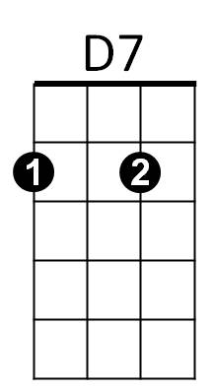


(Chorus)
G7
C

(OPTIONAL VERSES)

C
Mama works at the big hotel
Sister teaches school
G7
Brother works for the HPD
C
Papa makes his money playing pool

C
I want to marry this wahine I know
Her name is Haunani Ho
G7
I told my papa and he said no
Haunani is your sister
C
But your mama don't know

C
I told my mama what my papa had said
She said no hila hila
G7
You can marry Haunani Ho
Your papa's not your papa
C
But your papa don't know

(Chorus)

G7 C
You go Aala Park hi’amoe

VAMP: D7 G7 C (2X)



G7
D7
C
BARITONE

