Martha My Dear (Lennon / McCartney)

Intro: verse melody

C Am7 Em D C
Martha my dear though I spend my days in conver-sa-tion
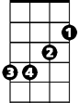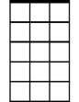D G
G
Em
D
C
Am7
Please remember me
F G7 F G
Martha, my love don't forget me
F G G F G
Martha, my dear

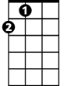Bm Em D
A
F
G7
Hold your head up, you silly girl, look what you've done
A Em
When you find yourself in the thick of it,
A Em F#m Bm
Help yourself to a bit of what is all a-round you,
Bm Em Em7
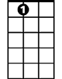You silly girl
A7

B m Em
Take a good look around you
Bm Em A7
Take a good look an d you’re bound to see, that you and me
G Bm Em Em7
Were mea nt to be with each other, you silly girl
BARITONE
Instrumental verse
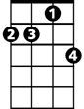
Em
D
Am7
C
Bm Em D
Hold your head up, you silly girl, see what you've done
A Em
When you find yourself in the thick of it,
A Em F#m Bm
Help yourself to a bit of what is all a-round you,
Bm Em Em7
G7
G
F
You silly girl

C Am7 Em D C
Martha, my dear, you have always been my inspi – ra-tion
D G
Please, be good to me,
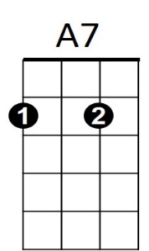
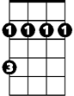F G7 F G
Em7
F#m
A
Bm
Martha, my love don't forget me
F G G F G C
Martha, my dear

