Maxwell’s Silver Hammer (Paul McCartney, John Lennon)

C A7
Joan was quizzical studied pataphysical
Dm
Science in the home
G7 C G7
Late nights all alone with a test tube oh oh oh oh
C A7
Maxwell Edison majoring in medicine
Dm
Calls her on the phone
G7 C G7
Can I take you out to the pictures Jo-o-o-oan
D7
But as she's getting ready to go
G7 Gdim G7
A knock comes on the door

Chorus:
C
Bang Bang Maxwell's silver hammer
D7
Came down upon her head
G7
Bang bang Maxwell's silver hammer
Dm G7 C G7 C
Made sure that she was dead

C/ E7/ Am/ C7/ F// G7// C/ G7/ C/

C A7
Back in school again Maxwell plays the fool again
Dm
Teacher gets annoyed
G7 C G7
Wishing to avoid an unpleasant sce e e ene
C A7
She tells Max to stay when the class has gone away
Dm
So he waits behind
G7 C G7
Writing fifty times I must not be so o o o
D7
But when she turns her back on the boy
G7 Gdim G7
He creeps up from behind

(Chorus)

(Instrumental Chorus)

C/ E7/ Am/ C7/ F/ G7/ C/ G7/ C/

C A7
P.C. Thirty-one said we caught a dirty one
Dm
Maxwell stands alone
G7 C G7
Painting testimonial pictures oh oh oh oh
C A7
Rose and Valerie screaming from the gallery
Dm
Say he must go free
G7 C G7
The judge does not agree and he tells them so-o-o-o
D7
But as the words are leaving his lips
G7 Gdim G7
A noise comes from behind

(Chorus)

(Instrumental Chorus)

C E7 Am C7 F// G7// C/ G7/ C/
Sil - ver Ham - mer


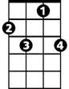
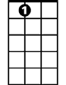

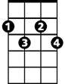

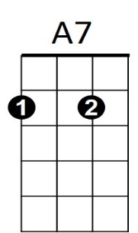


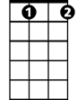

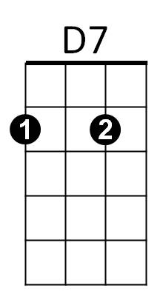
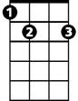
F
BARITONE
C
C7
E7
D7
Gdim
Dm
G7
C
Gdim
G7
Dm
A7
F
C7
E7

