May Day is Lei Day in Hawaii


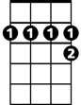
VAMP: G7 C7 F 2X
F
C7
D7
F C7
May Day is Lei Day in Hawaii
F
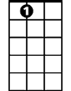

Garlands of flowers everywhere
A7
G7
D7 G7
All of the colors in the rainbow
C7
Maidens with blossoms in their hair

F C7
Flowers that mean we should be happy
F A7
Throwing aside a load of care - Oh
D7 G7
May Day is Lei Day in Hawaii

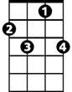
C7 F
BARITONE
D7
F
C7
Lei Day is happy days out here

VAMP 2x

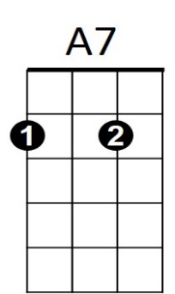
(REPEAT SONG)
G7

